CS 342000 | CS343000  
Instructor: Professor Izidor Gertner

Spring 2022

Azwad Shameem, 4/10/2022

Laboratory Project: Design Arithmetic Logic Unit

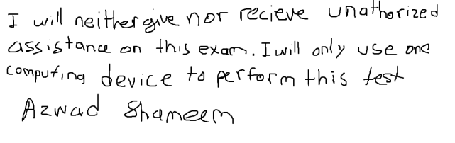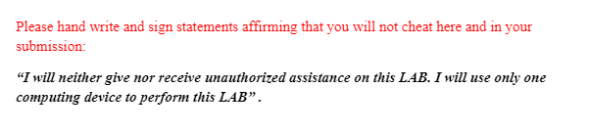

Table of Contents

Objective 3

Description of Functionality and Simulation 4

Functionality: 4

RS Register 4

RT Register 5

RD Register 6

N-Bit AddSub with Flags Unit 7

Bitwise Operations Unit 8

IMM16 Register 9

Sign Extender Unit 10

MAR – Memory Address Register 11

MDR – Memory Data Register 12

ALU – Arithmetic Logic Unit 13

3 Ported RAM 18

Instruction Register 23

Data Memory 28

Simulation: 30

Part I.A 30

Part I.B 44

Part II 50

Part III 58

Part IV 60

Conclusion: 62

# Objective

The objective of the Arithmetic Logic Unit lab was to implement MIPS instructions in VHDL. MIPS instructions such as ADD, ADDU, SUB, SUBU, AND, NOR, OR, SLL, SRA, ADDI, ADDIU, ANDI, ORI, LW, SW was all intended to be implements by VHDL programming. The VHDL program was then to be tested by utilizing ModelSim simulations to create waveforms for select cases that would show the results of the MIPS instructions that were implemented in VHDL. Furthermore, in order to ascertain correctness of the VHDL implementation of MIPS instructions we had to compare the MIPS instructions that ran on the MARS environment with the ModelSim simulation waveforms to confirm the correctness of the VHDL implementation of the MIPS instructions.

# Description of Functionality and Simulation

## Functionality:

### Graphical user interface, text, application Description automatically generatedRS Register

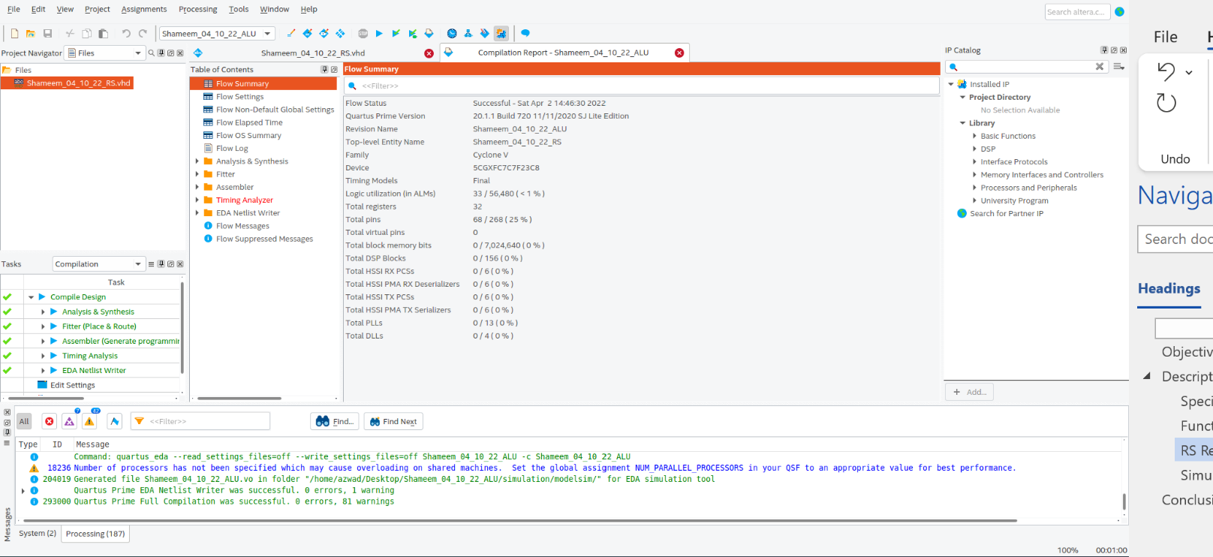Figure 1: RS Register VHDL code compiled successfully in Quartus.

Figure 2: RS Register compilation report in Quartus.

### RT Register

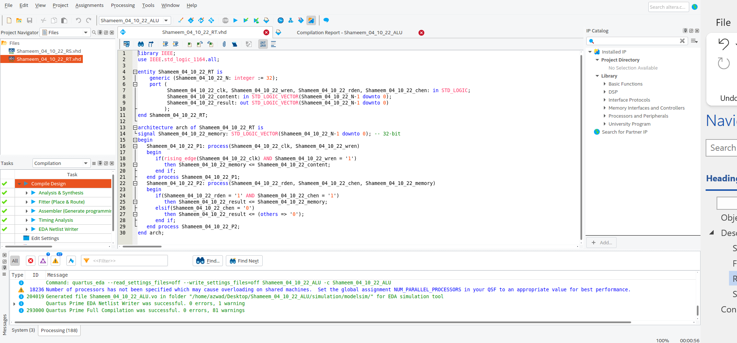Figure 3: RT Register VHDL code compiled successfully in Quartus.

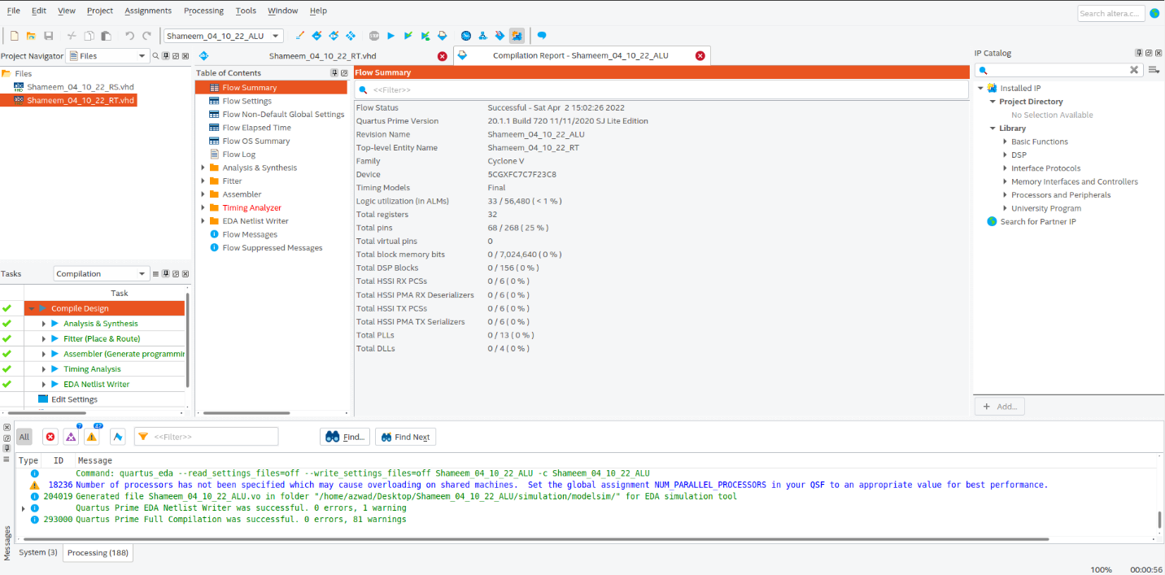 Figure 4: RT Register compilation report in Quartus.

.

### Graphical user interface, text, application, email Description automatically generatedRD Register

Figure 5: RD Register VHDL code compiled successfully in Quartus.

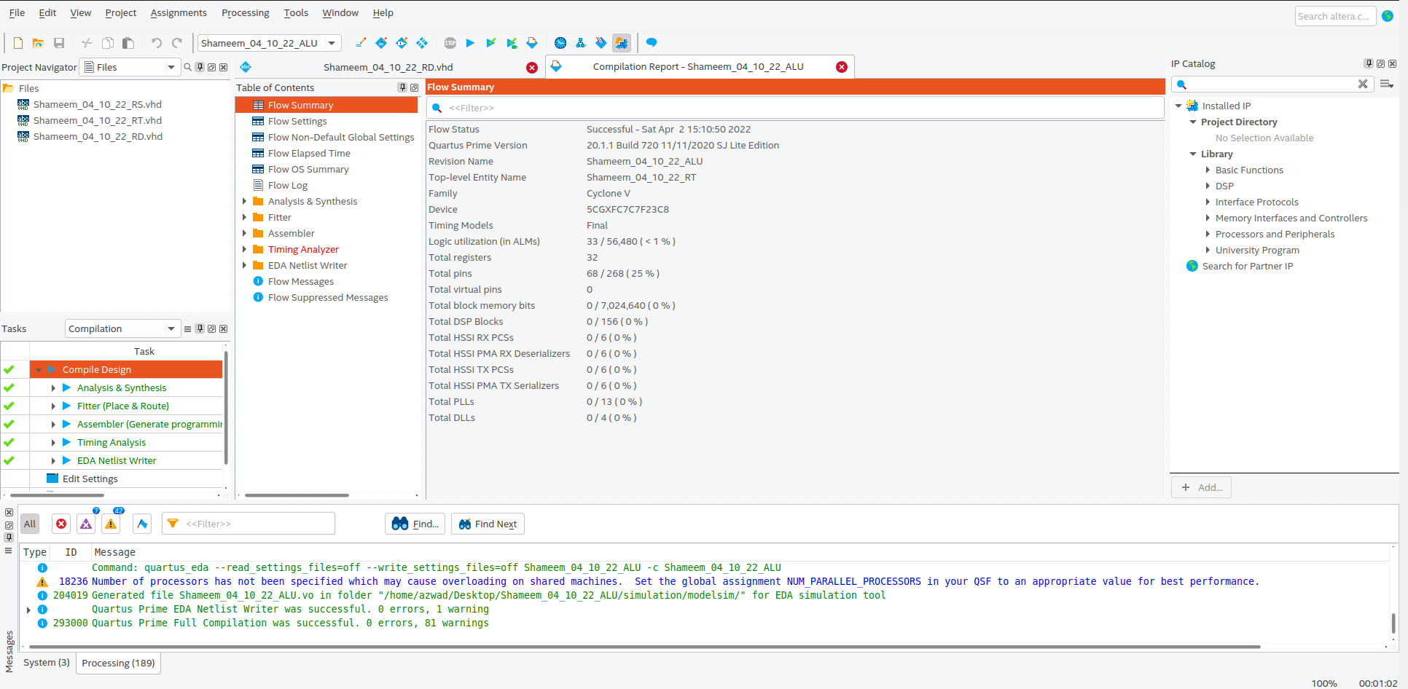

Figure 6: RT Register compilation report in Quartus.

### Graphical user interface, text, application Description automatically generated N-Bit AddSub with Flags Unit

Figure 7: N-Bit AddSub with Flags VHDL code compiled successfully in Quartus.

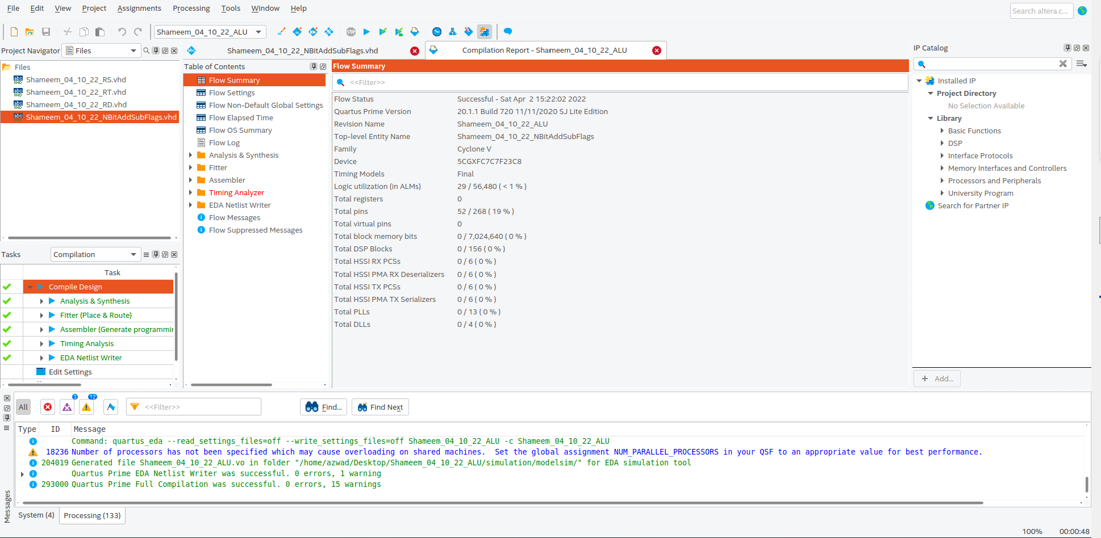

Figure 8: N-Bit AddSub with Flags compilation report in Quartus.

### Text Description automatically generatedBitwise Operations Unit

Figure 9: Bitwise Operations VHDL code compiled successfully in Quartus.

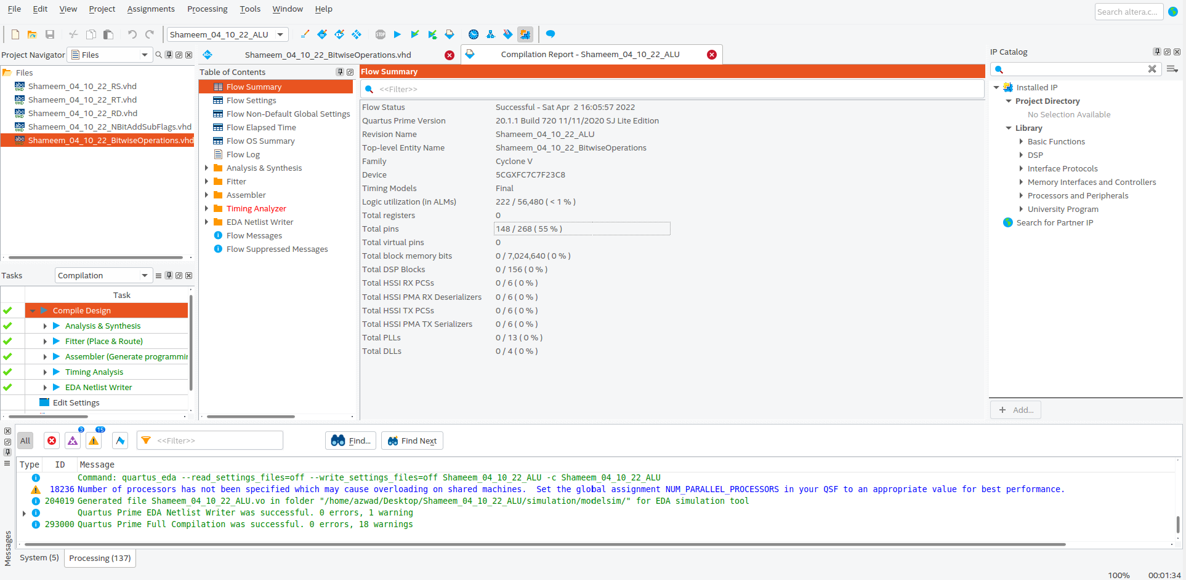

Figure 10: Bitwise Operations compilation report in Quartus.

### Graphical user interface, text, application Description automatically generatedIMM16 Register

Figure 11: IMM16 Register VHDL code compiled successfully in Quartus.

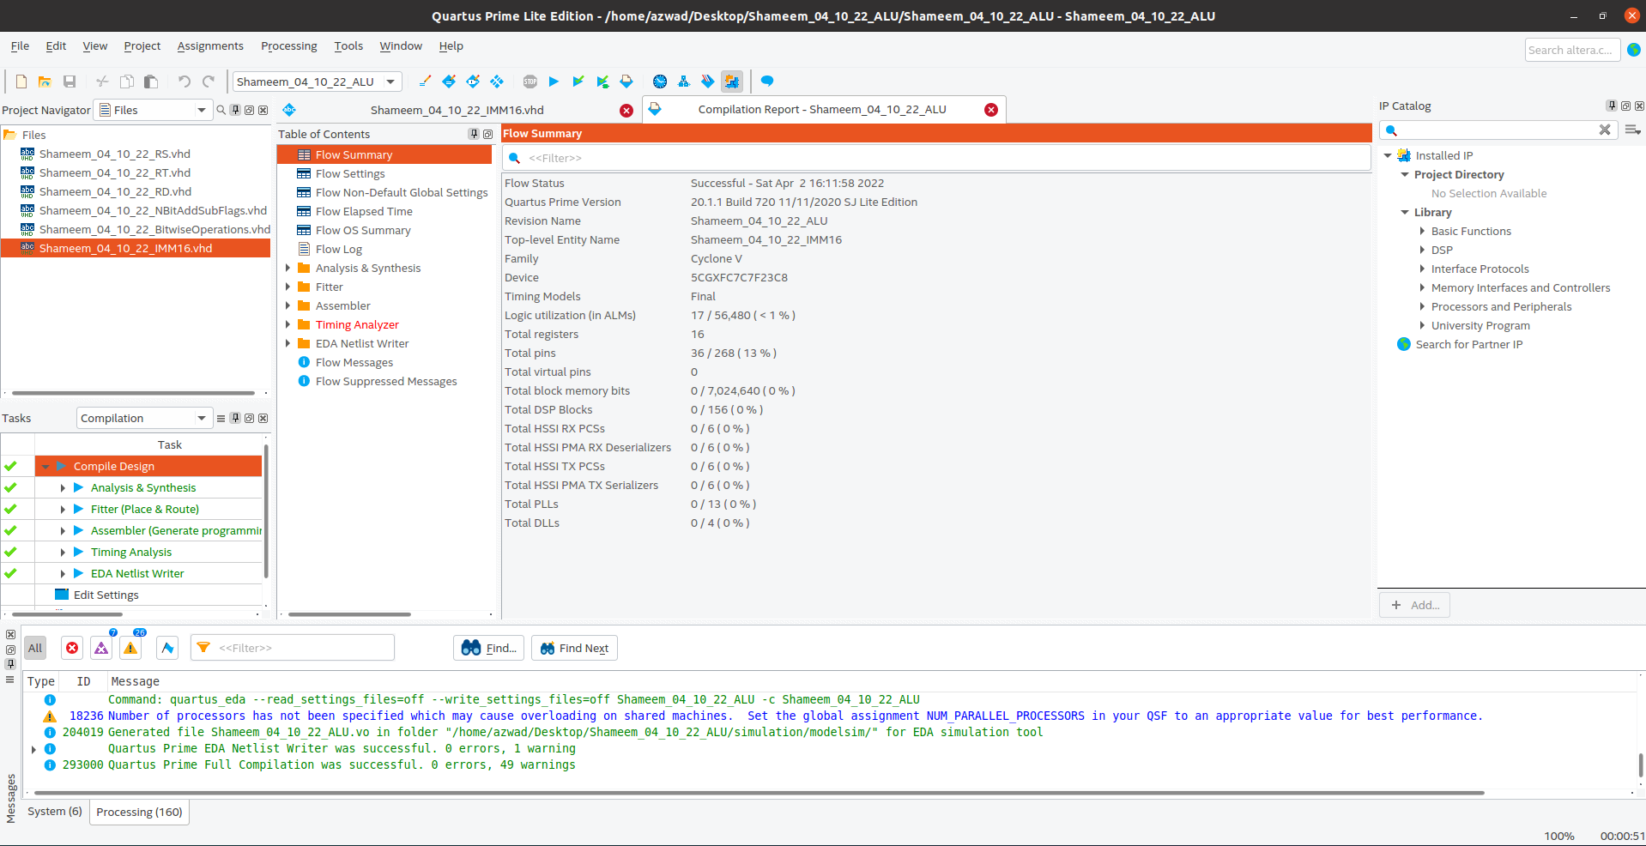

Figure 12: IMM16 Register compilation report in Quartus.

### Graphical user interface, text, application, email Description automatically generatedSign Extender Unit

Figure 13: Sign Extender VHDL code compiled successfully in Quartus.

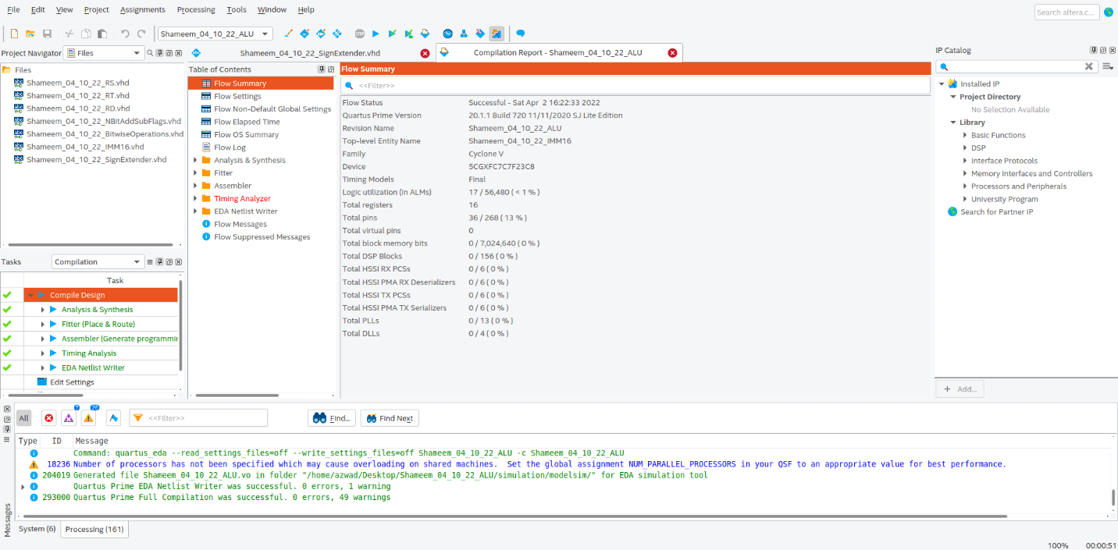

Figure 14: Sign Extender compilation report in Quartus.

### MAR – Memory Address Register

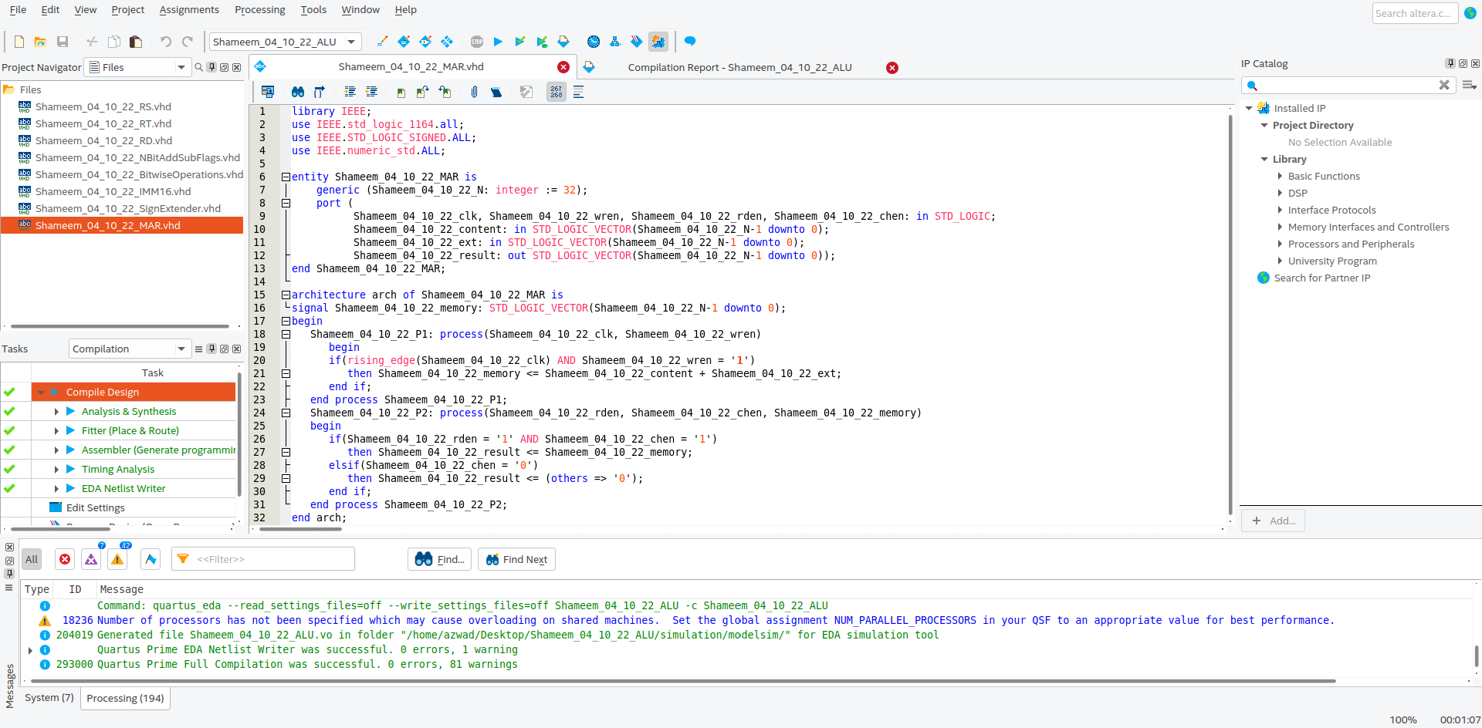

Figure 15: Memory Address Register VHDL code compiled successfully in Quartus.

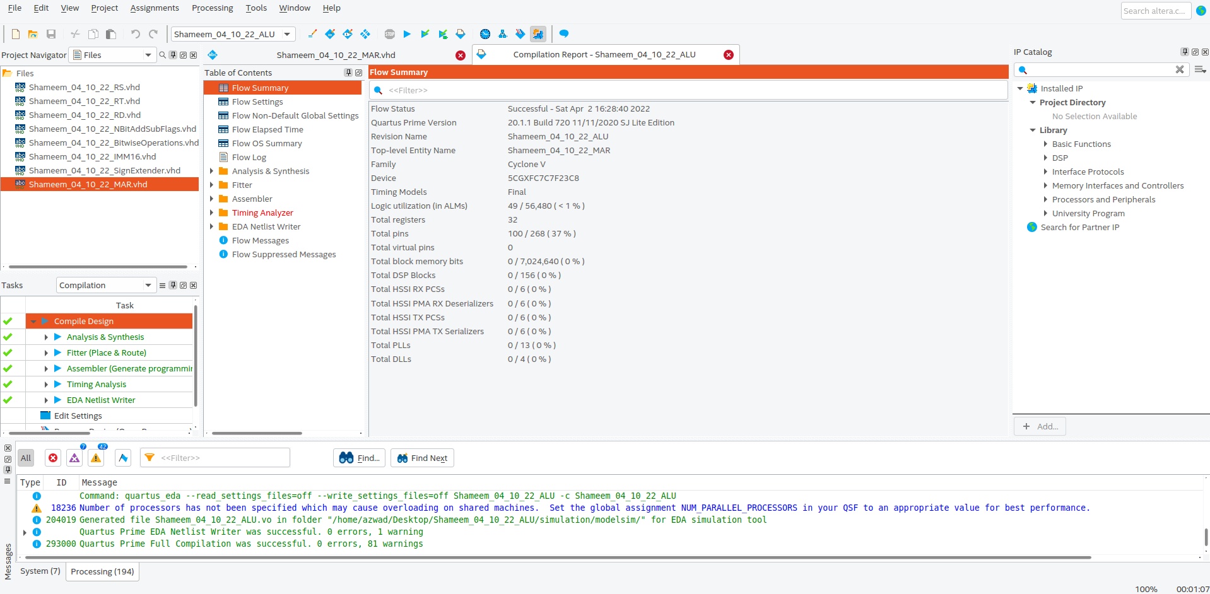

Figure 16: Memory Address Register compilation report in Quartus.

### Graphical user interface, text, application Description automatically generatedMDR – Memory Data Register

Figure 17: Memory Data Register VHDL code compiled successfully in Quartus.



Figure 18: Memory Data Register compilation report in Quartus.

### Graphical user interface, text, application Description automatically generatedALU – Arithmetic Logic Unit

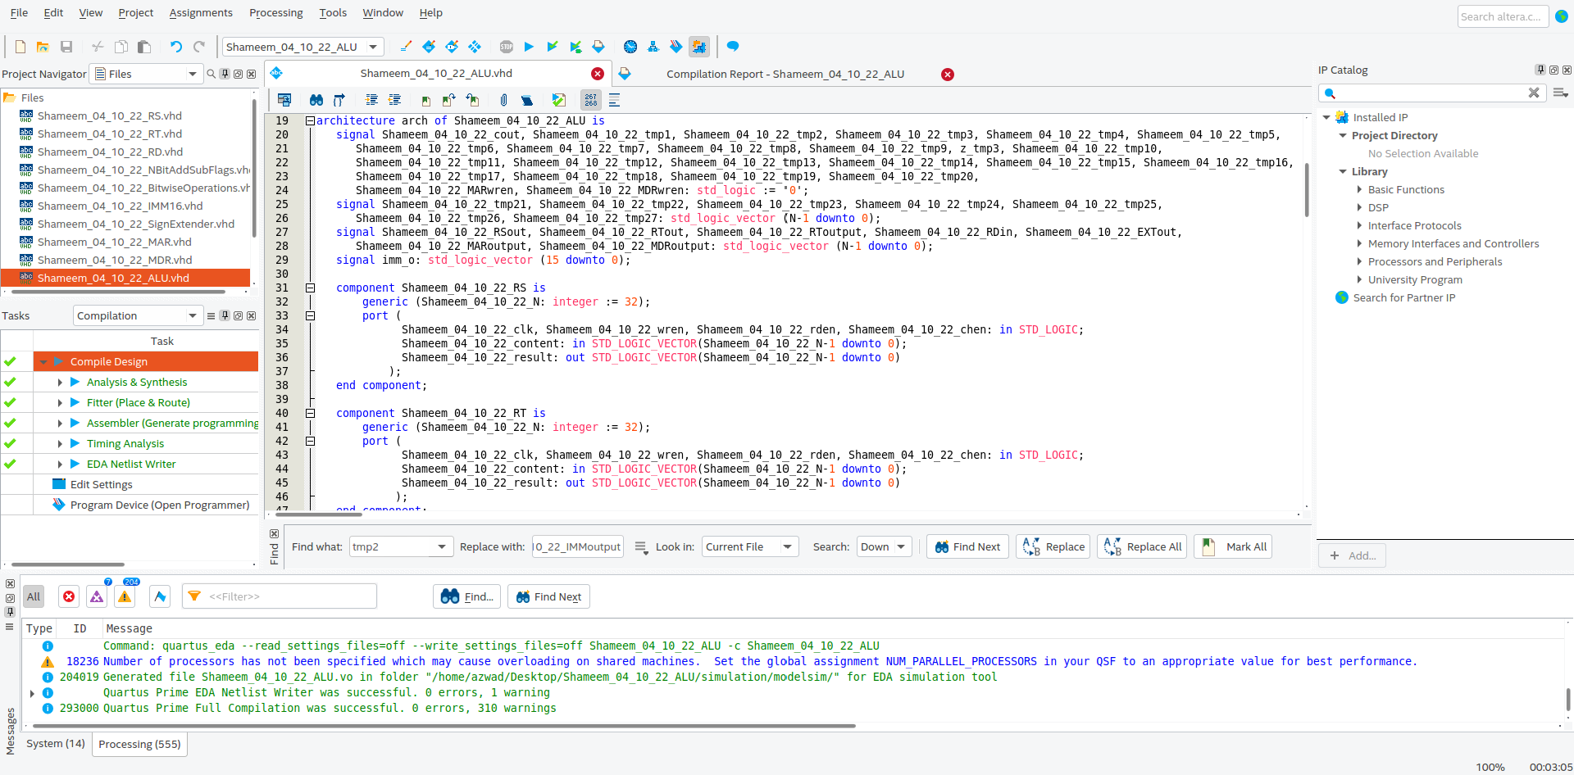Figure 19: Arithmetic Logic Unit VHDL code compiled successfully in Quartus.

Figure 20: Arithmetic Logic Unit VHDL code continued.

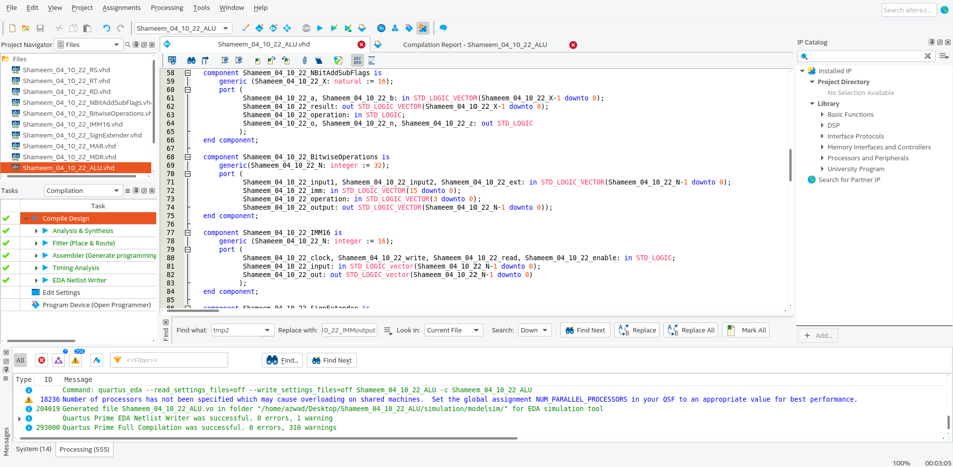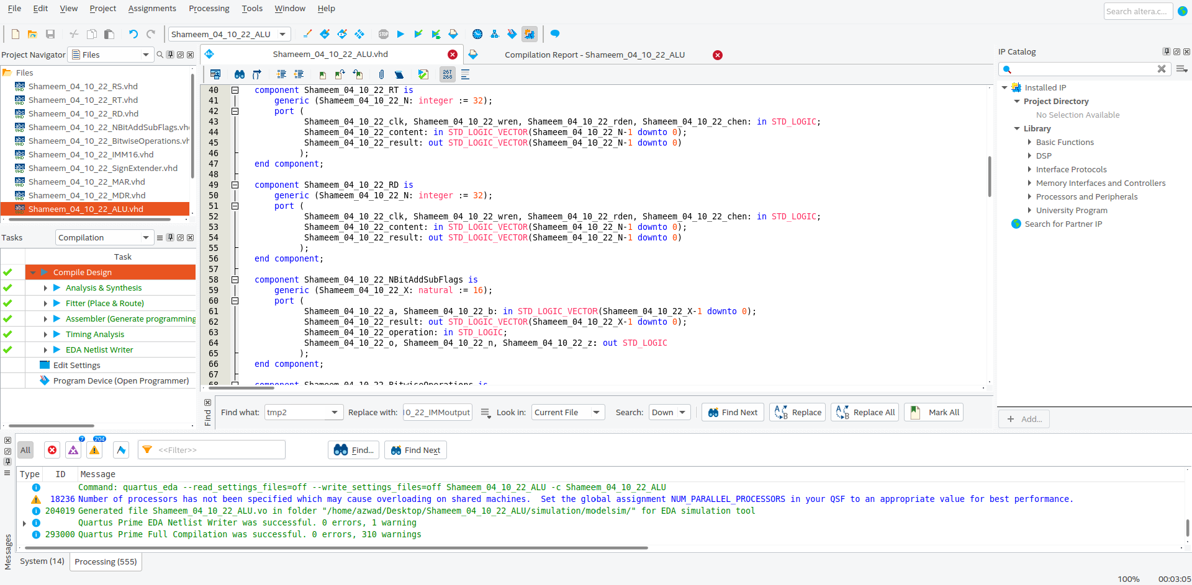Figure 21: Arithmetic Logic Unit VHDL code continued.

Figure 22: Arithmetic Logic Unit VHDL code continued

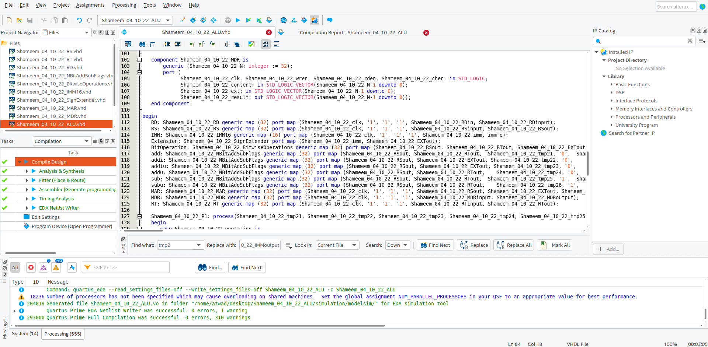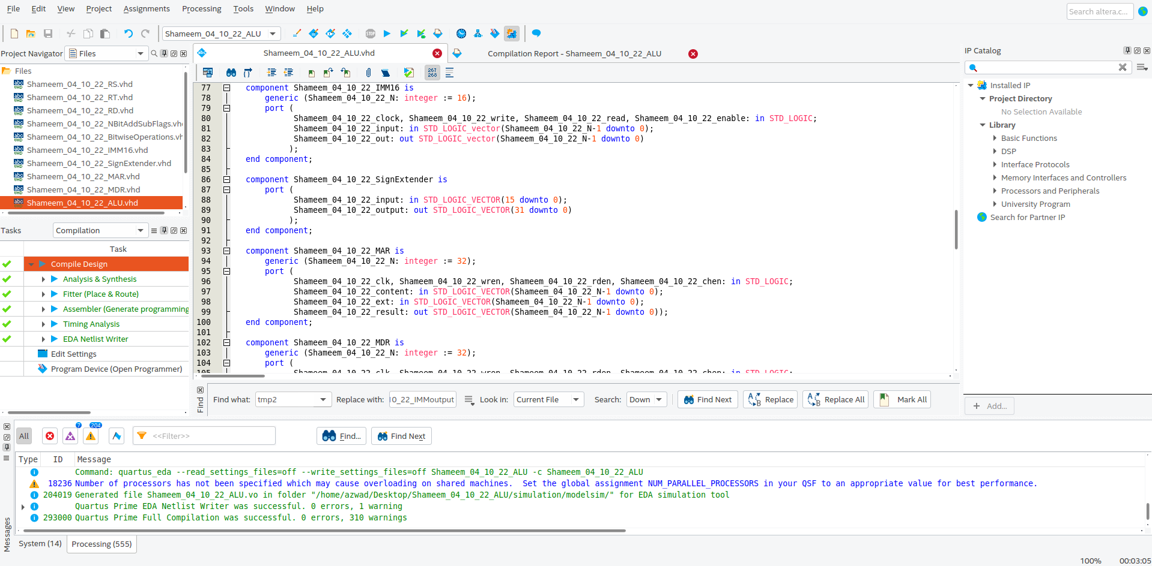Figure 23: Arithmetic Logic Unit VHDL code continued.

Figure 24: Arithmetic Logic Unit VHDL code continued.

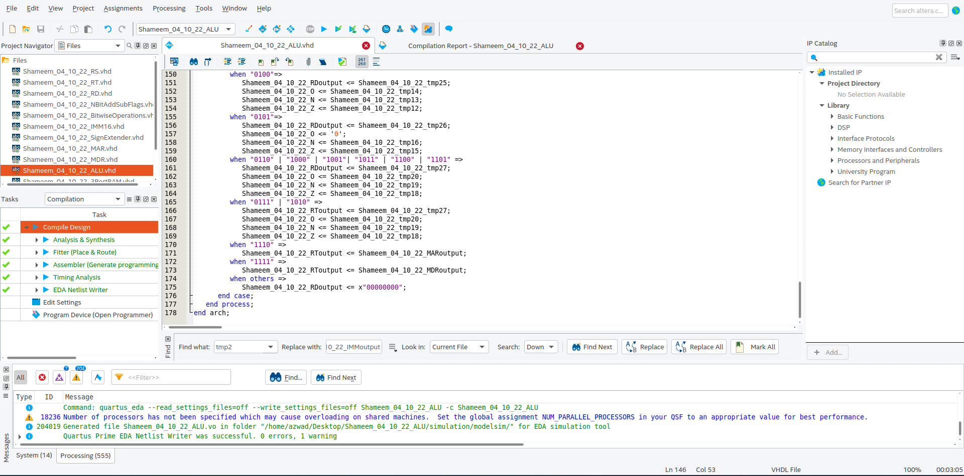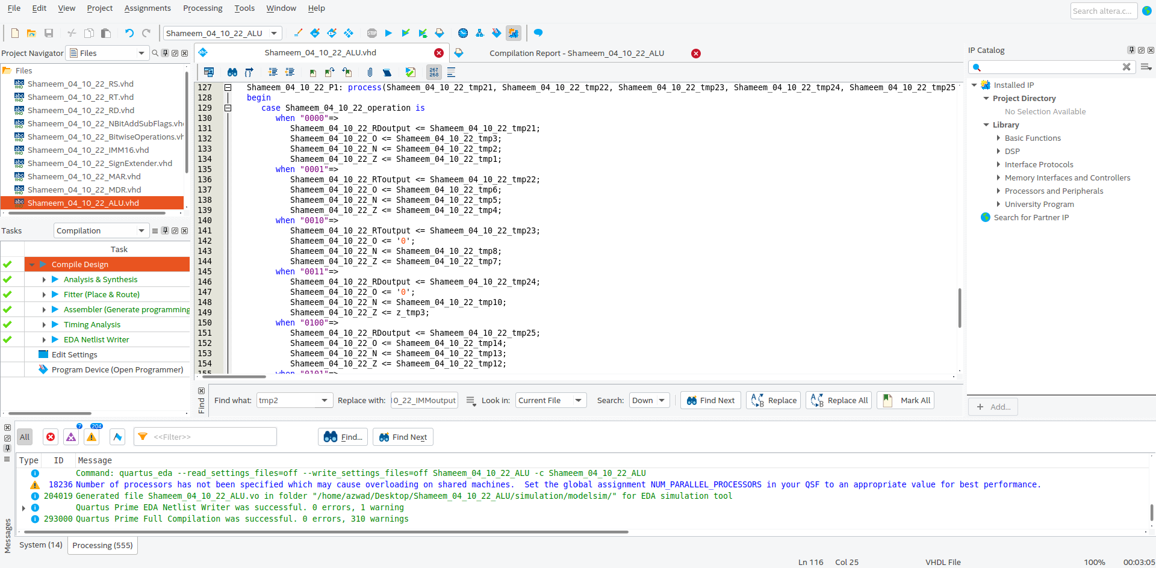Figure 25: Arithmetic Logic Unit VHDL code continued.

Figure 26: Arithmetic Logic Unit VHDL code continued.

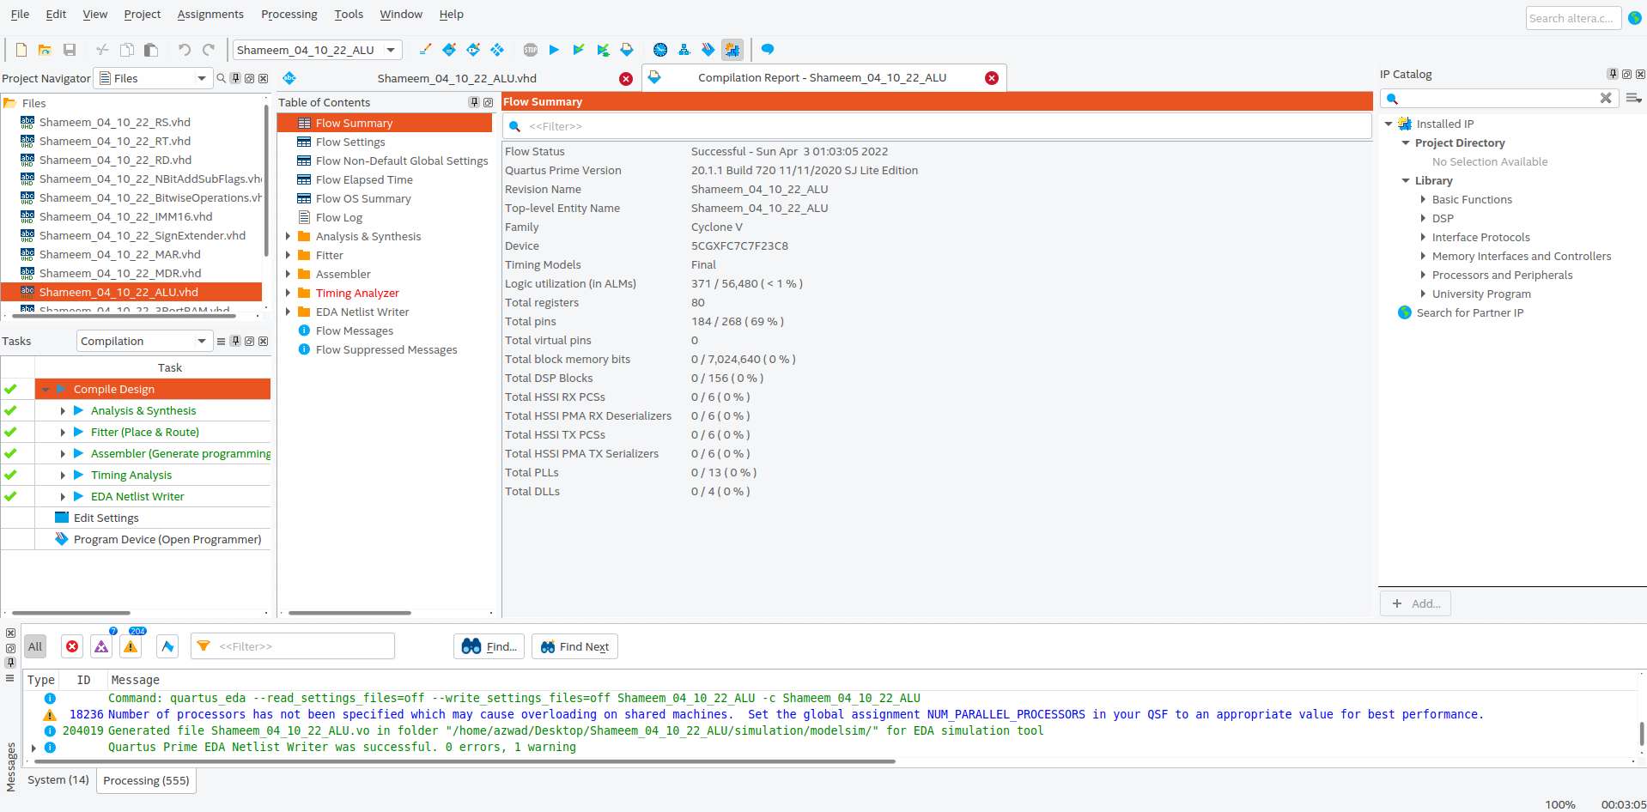

Figure 27: Arithmetic Logic Unit compilation report.

### Graphical user interface, text, application Description automatically generated3 Ported RAM

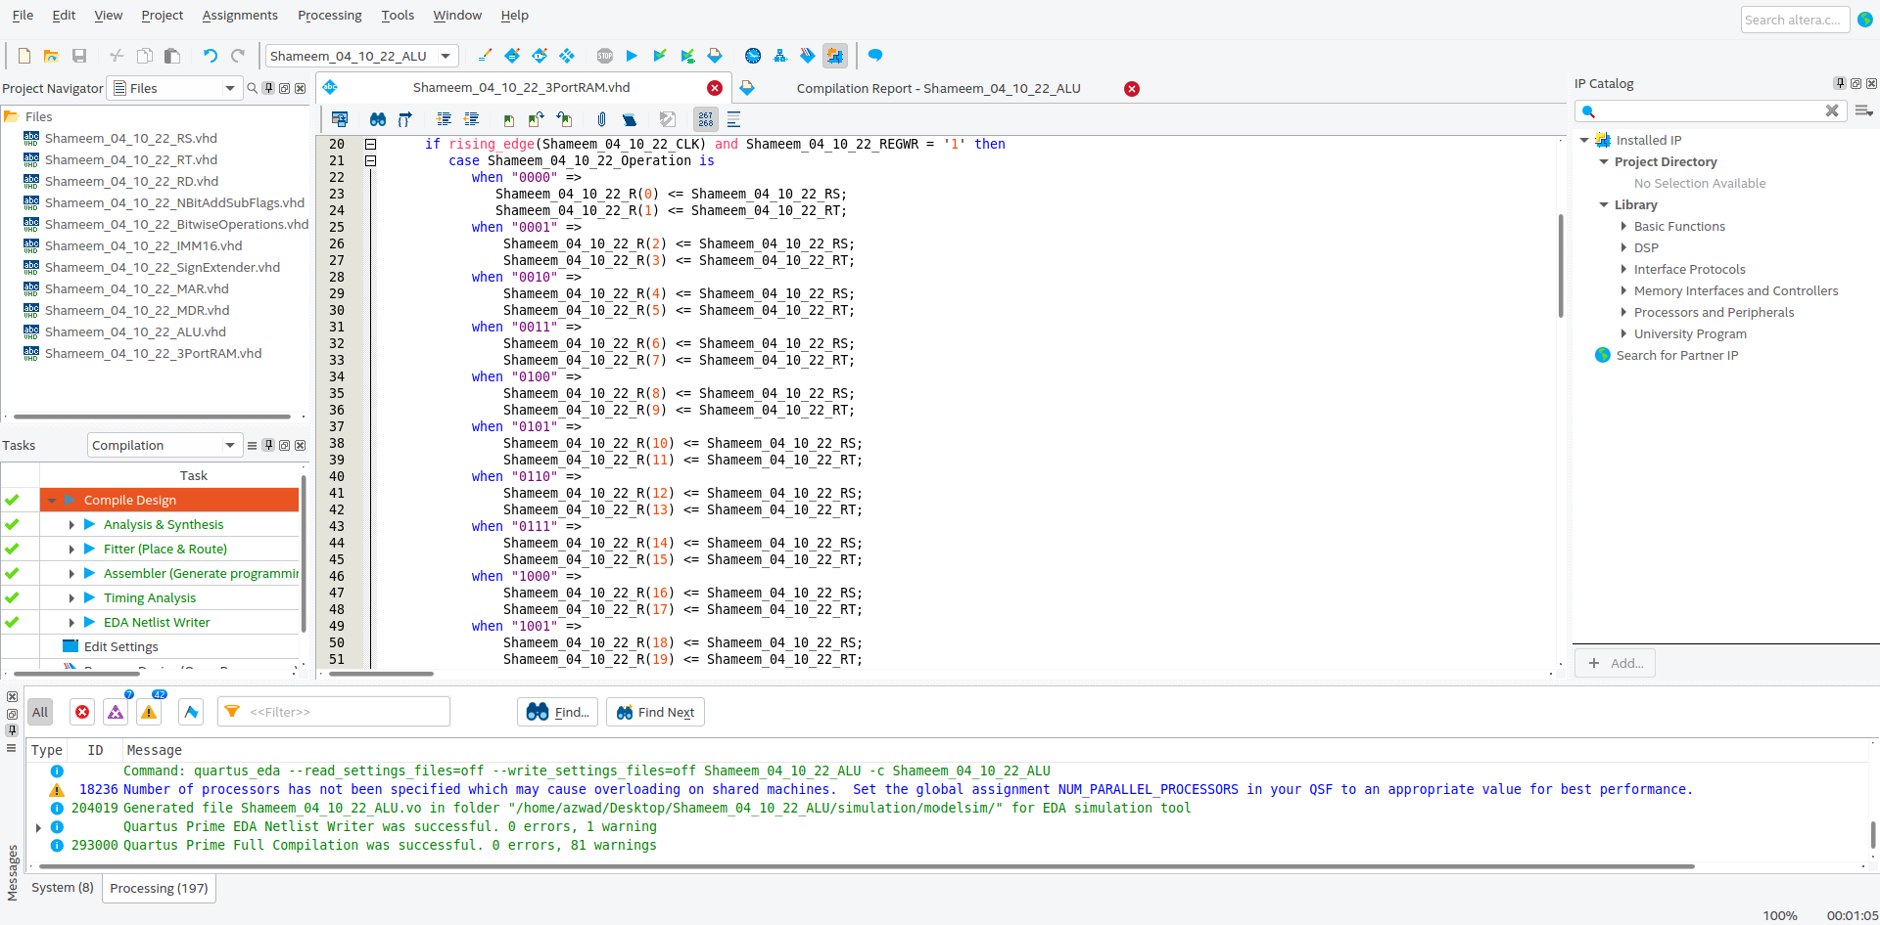Figure 28: 3 Ported RAM VHDL code compiled successfully on Quartus.

Figure 29: 3 Ported RAM VHDL code continued.

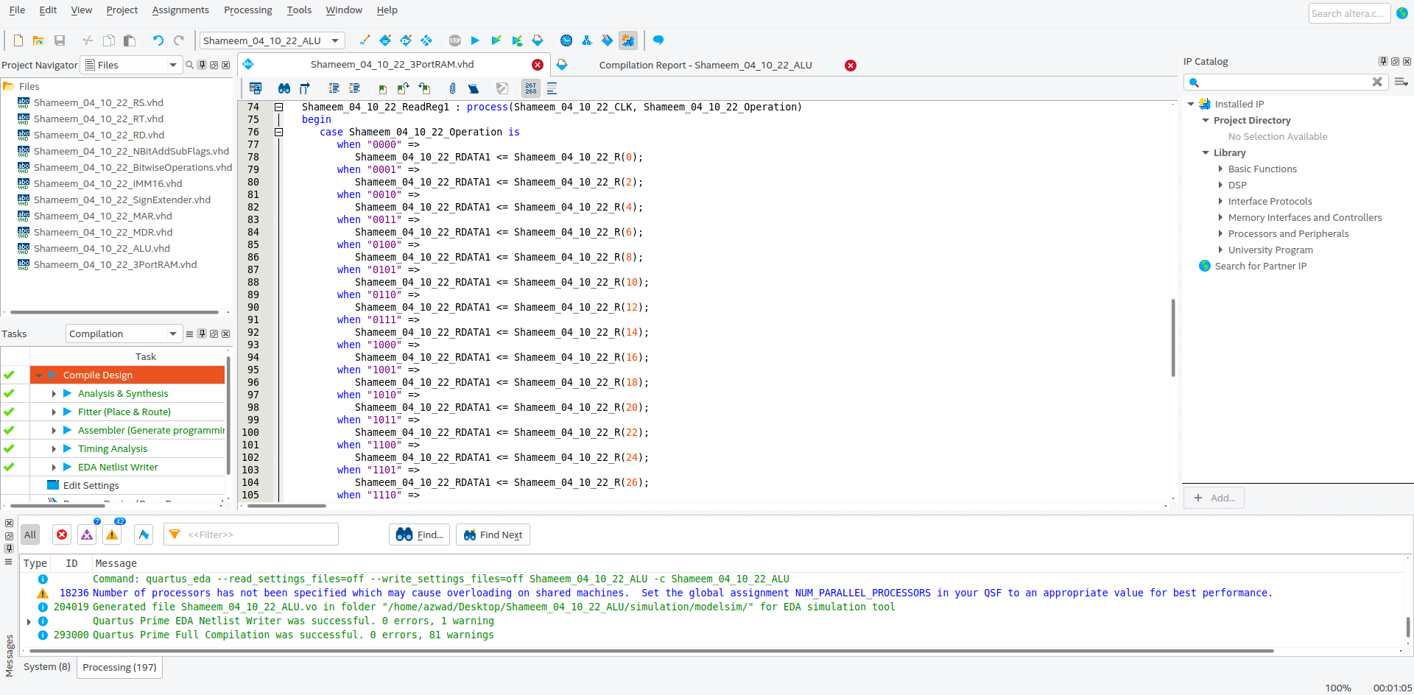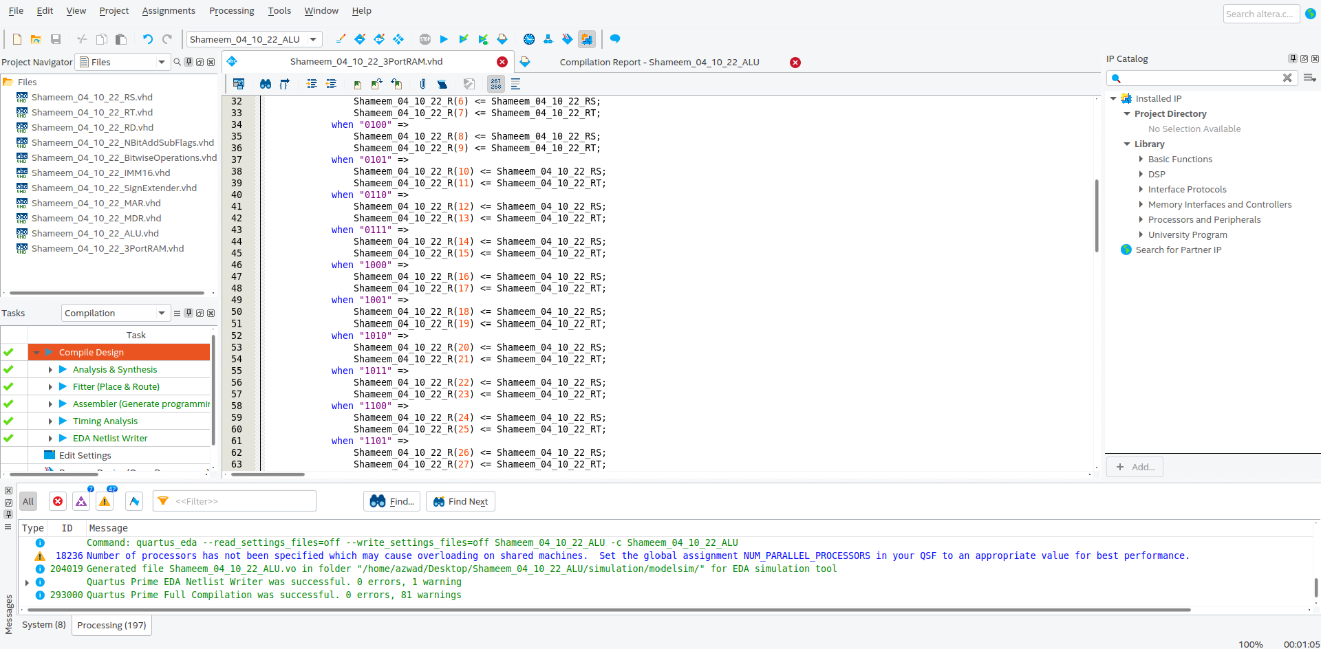Figure 30: 3 Ported RAM VHDL code continued.

Figure 31: 3 Ported RAM VHDL code continued.

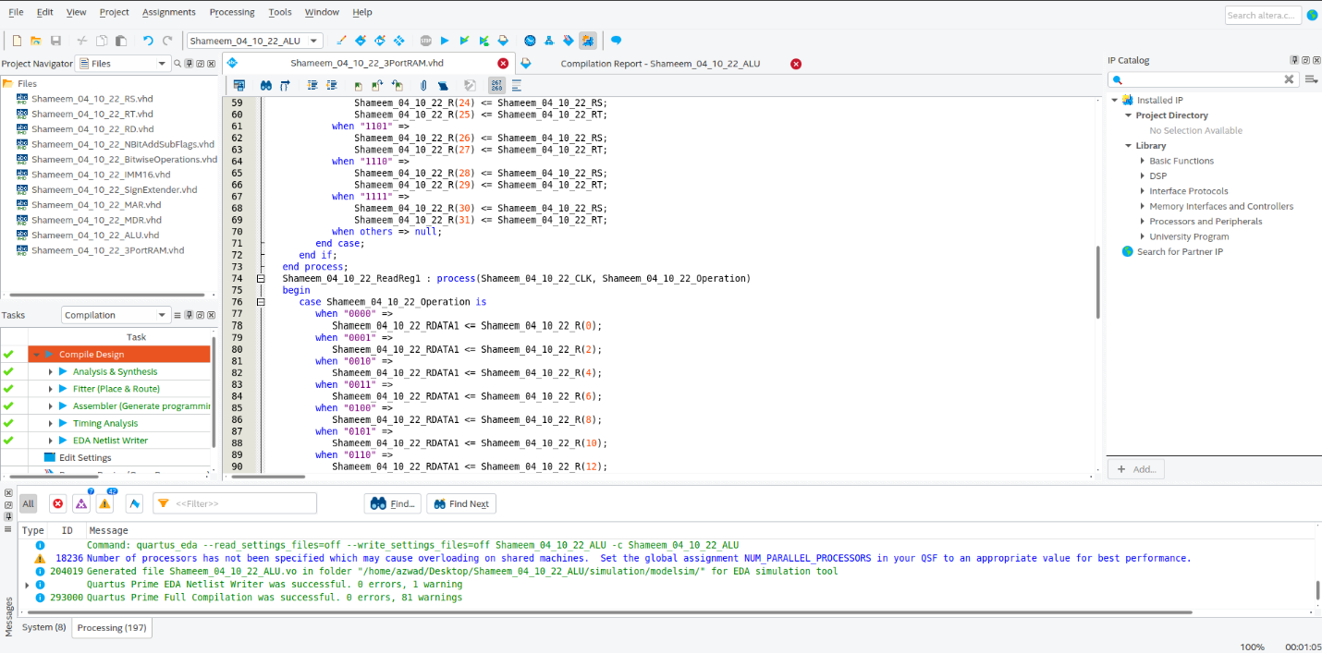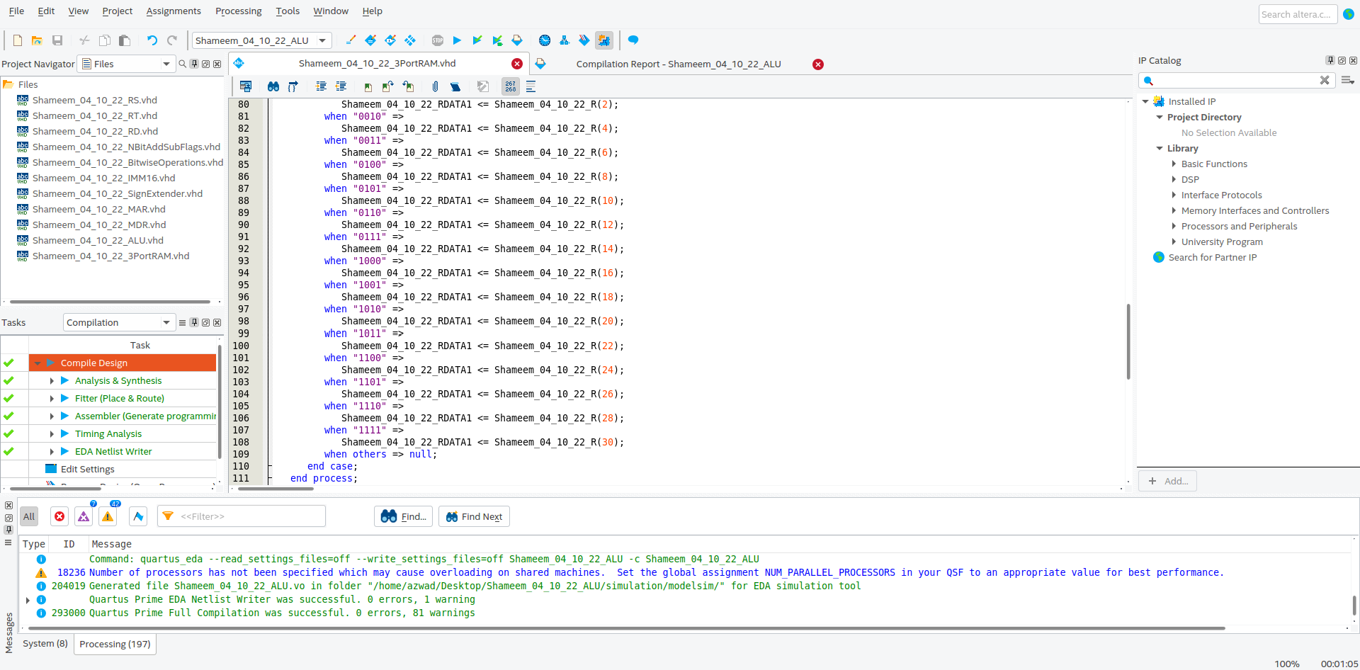Figure 32: 3 Ported RAM VHDL code continued.

Figure 33: 3 Ported RAM VHDL code continued.

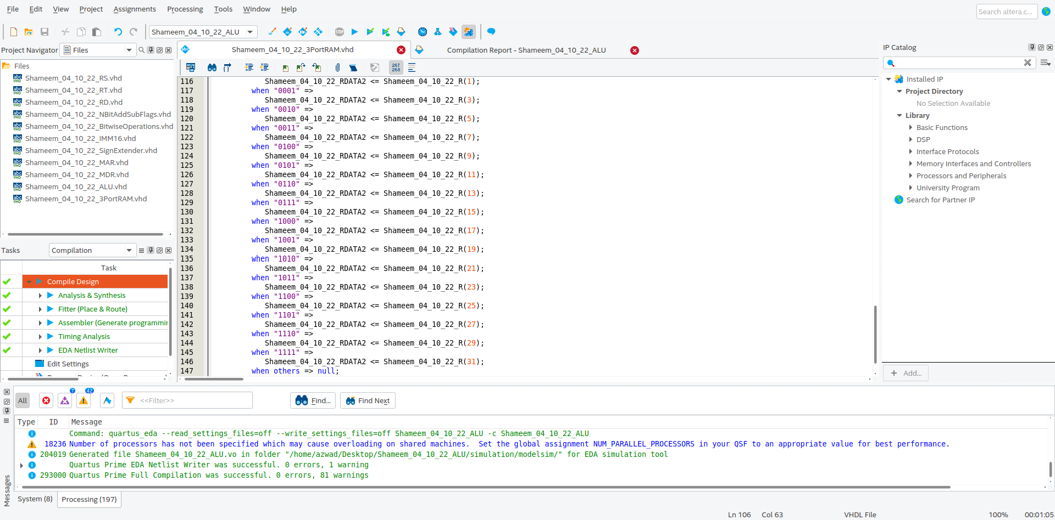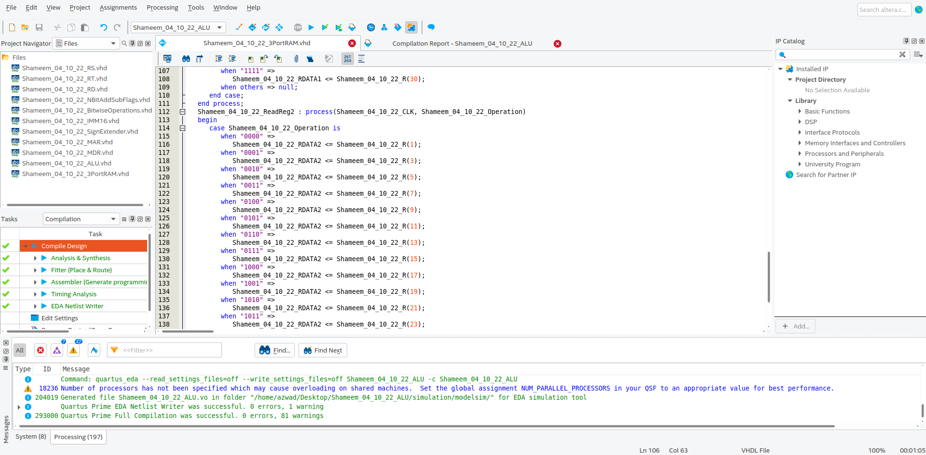Figure 34: 3 Ported RAM VHDL code continued.

Figure 35: 3 Ported RAM VHDL code continued.

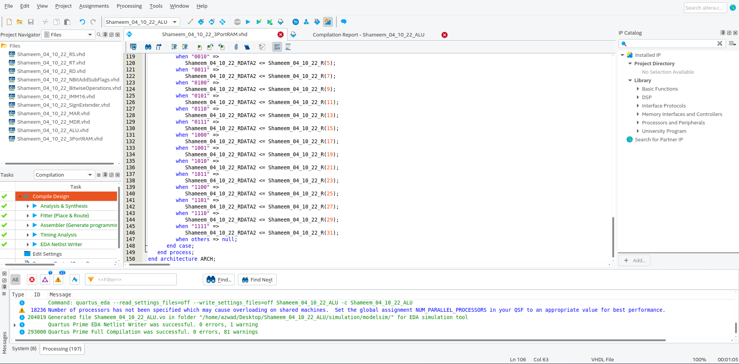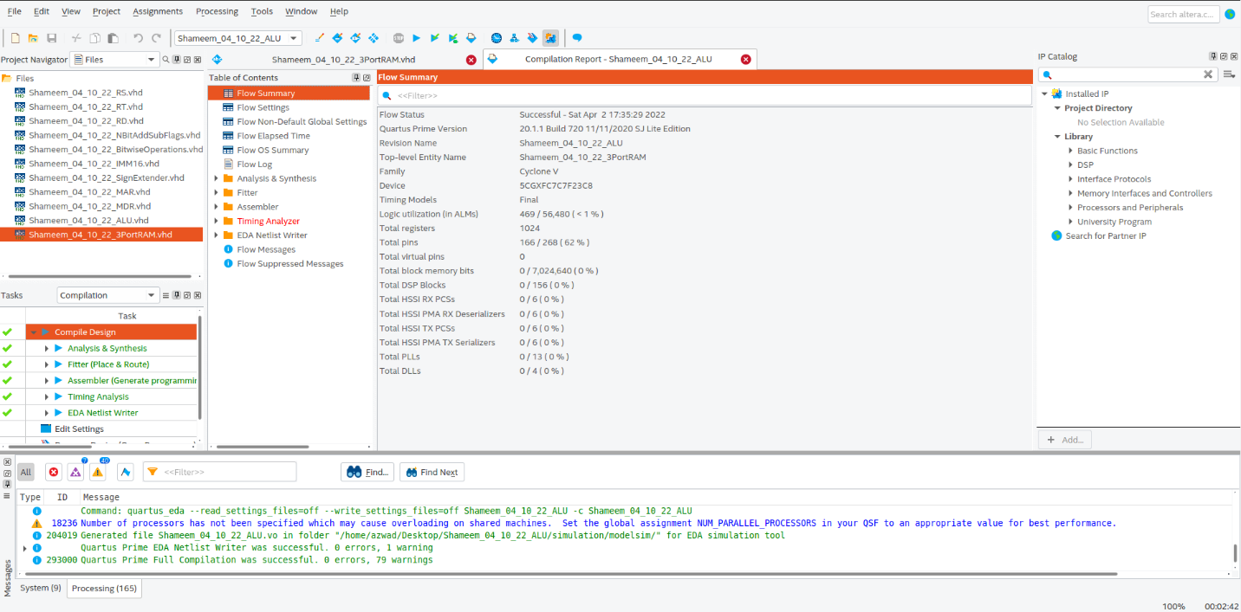Figure 36: 3 Ported RAM VHDL code continued.

Figure 37: 3 Ported RAM compilation report

### Graphical user interface, text, application, email Description automatically generatedInstruction Register

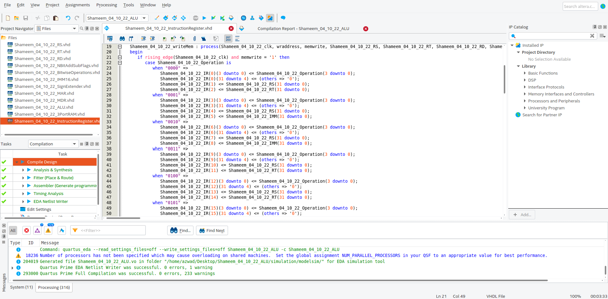Figure 38: Instruction Register VHDL code compiled successfully in Quartus.

Figure 39: Instruction Register VHDL code continued.

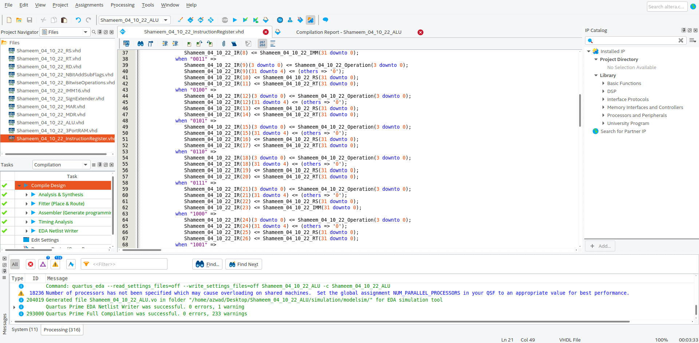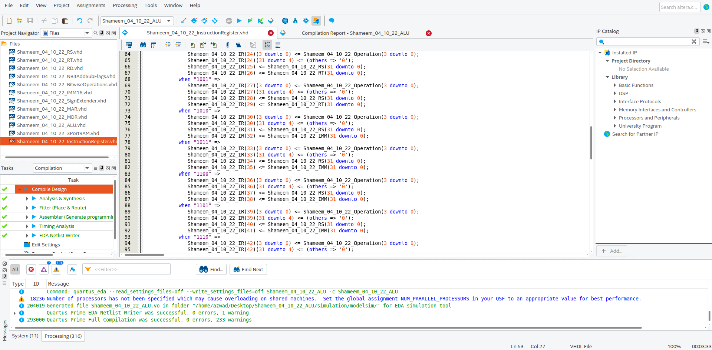Figure 40: Instruction Register VHDL code continued.

Figure 41: Instruction Register VHDL code continued.

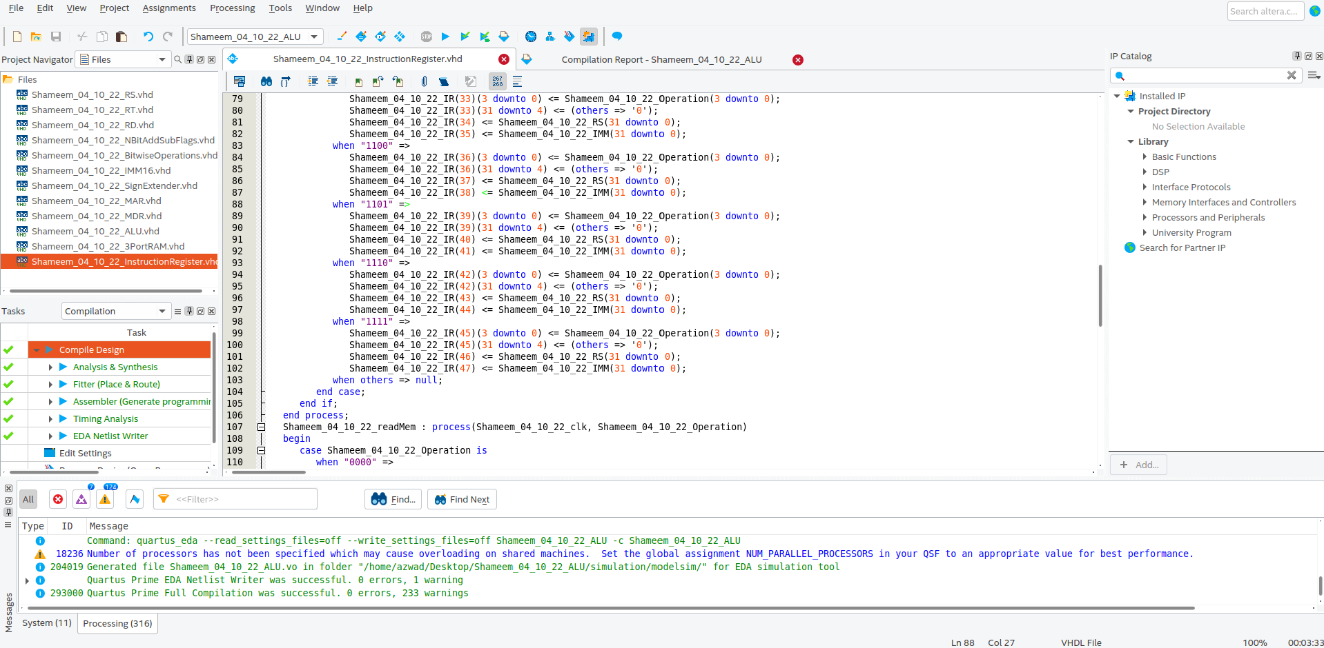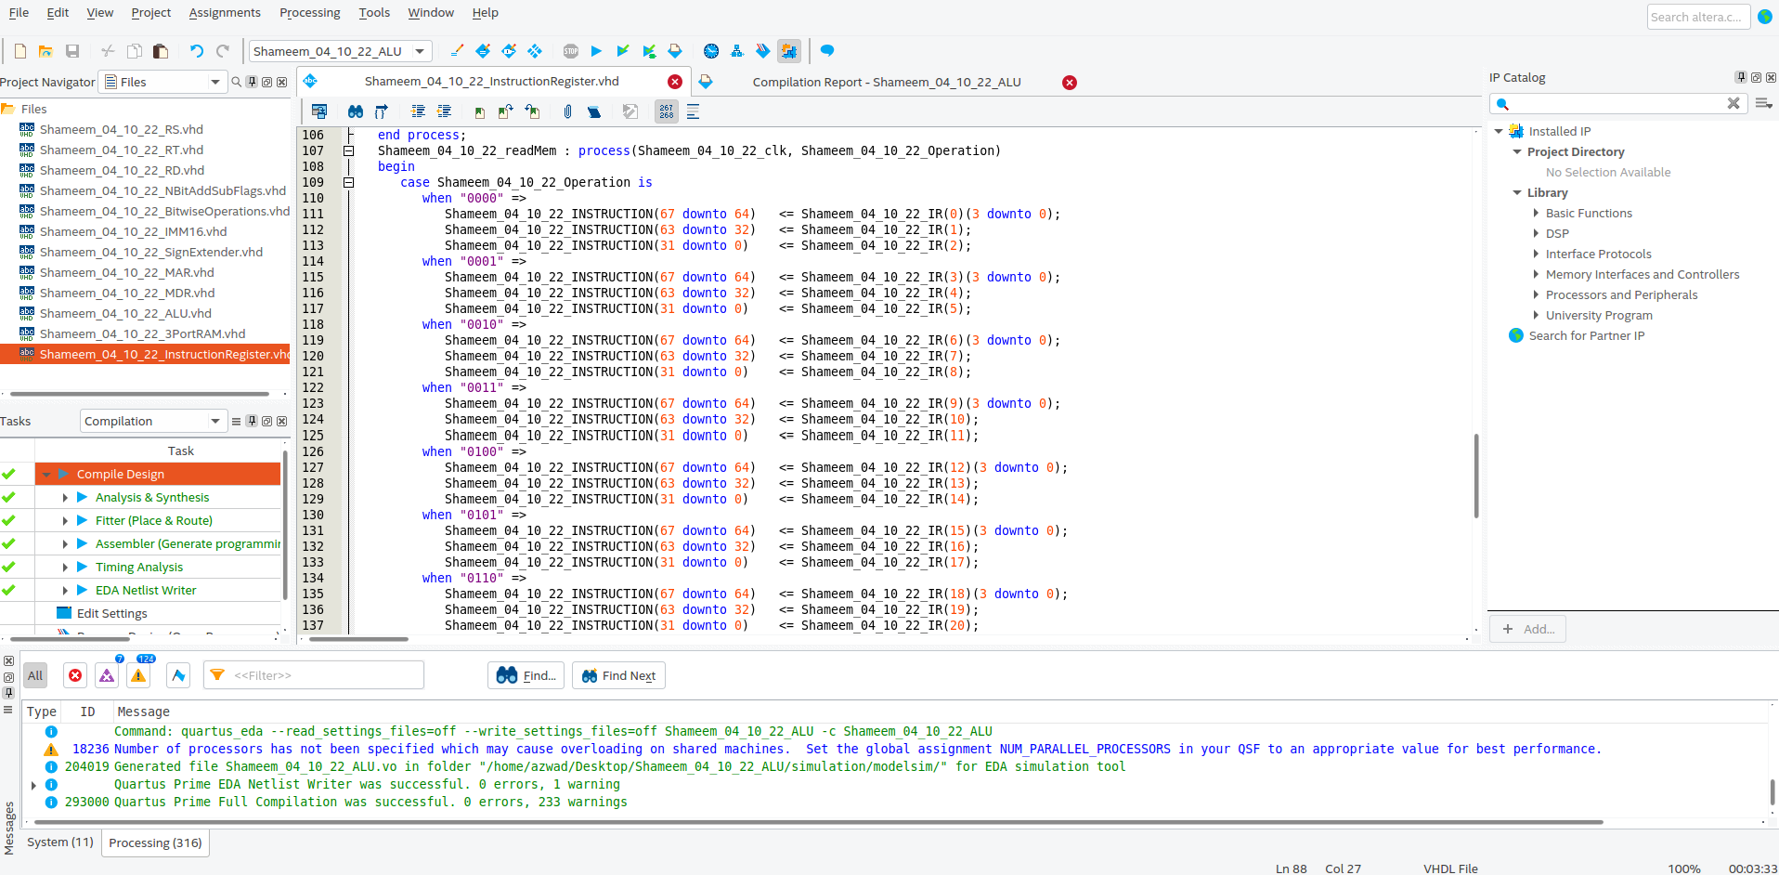Figure 42: Instruction Register VHDL code continued.

Figure 43: Instruction Register VHDL code continued.

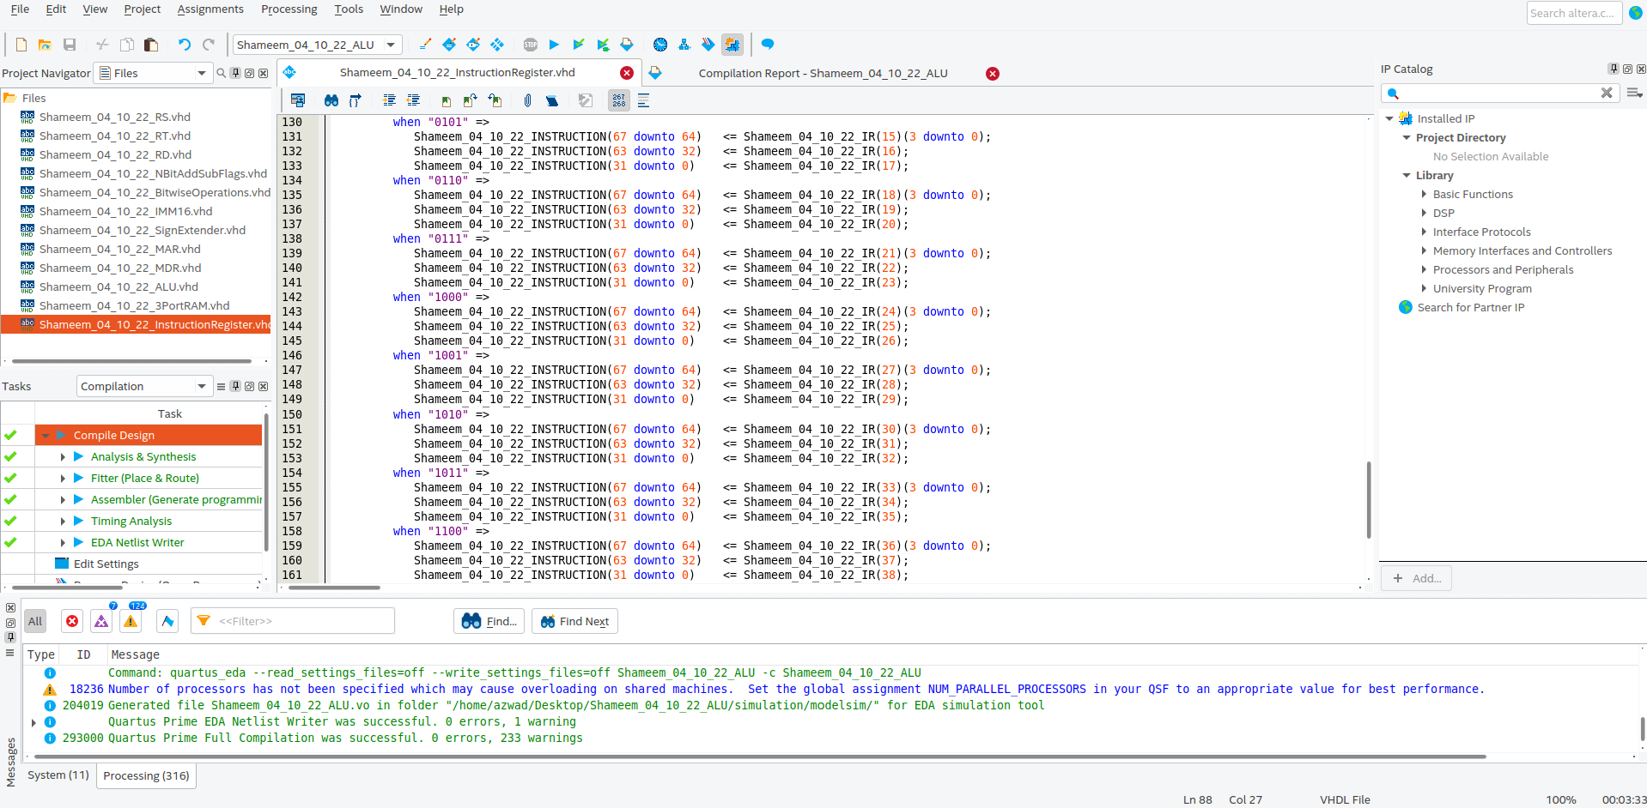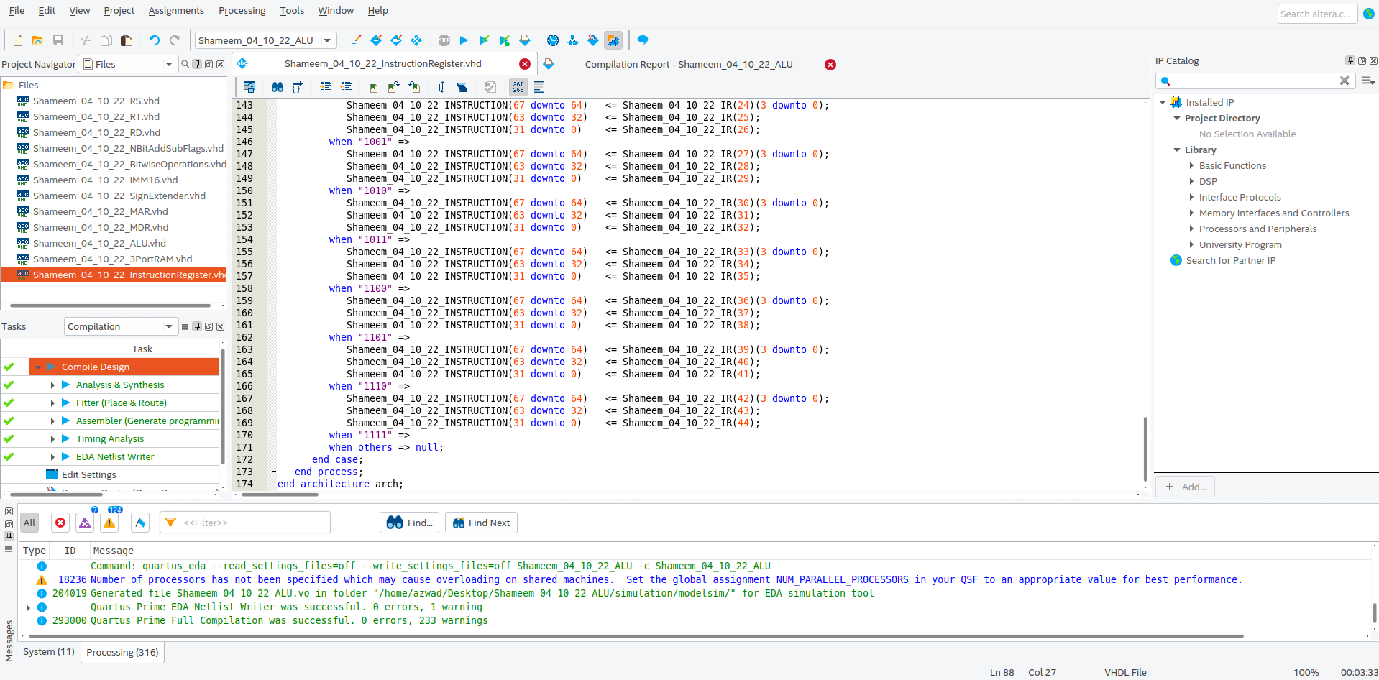Figure 44: Instruction Register VHDL code continued.

Figure 45: Instruction Register VHDL code continued.

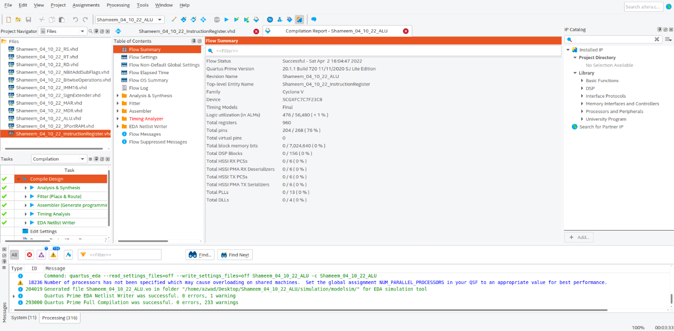Figure 46: Instruction Register compilation report.

### Graphical user interface, text, application, email Description automatically generatedData Memory

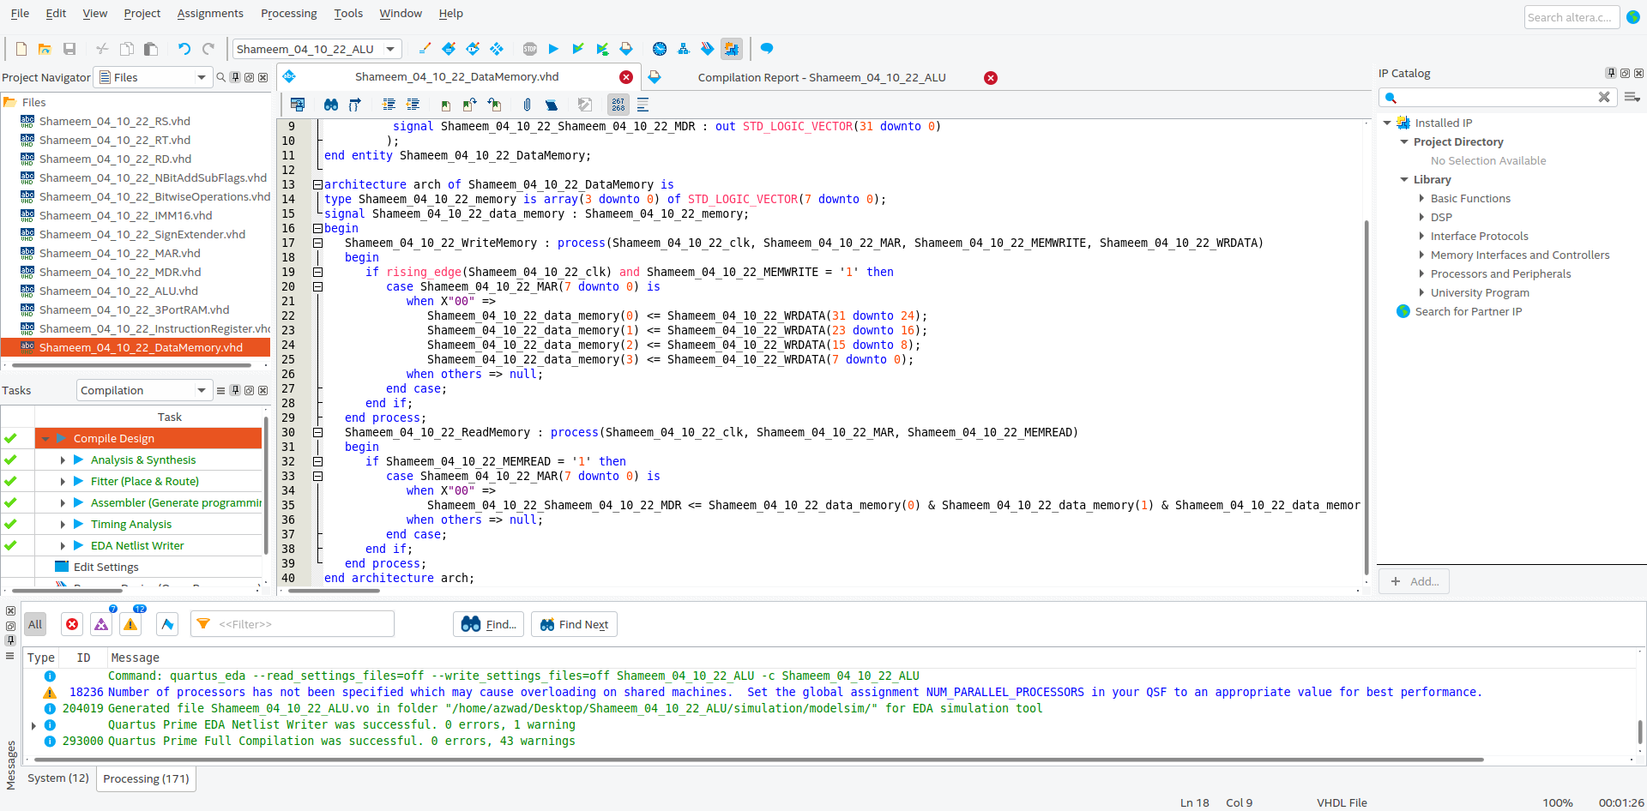Figure 47: Data Memory VHDL code compiled successfully in Quartus

Figure 48: Data Memory VHDL code continued.

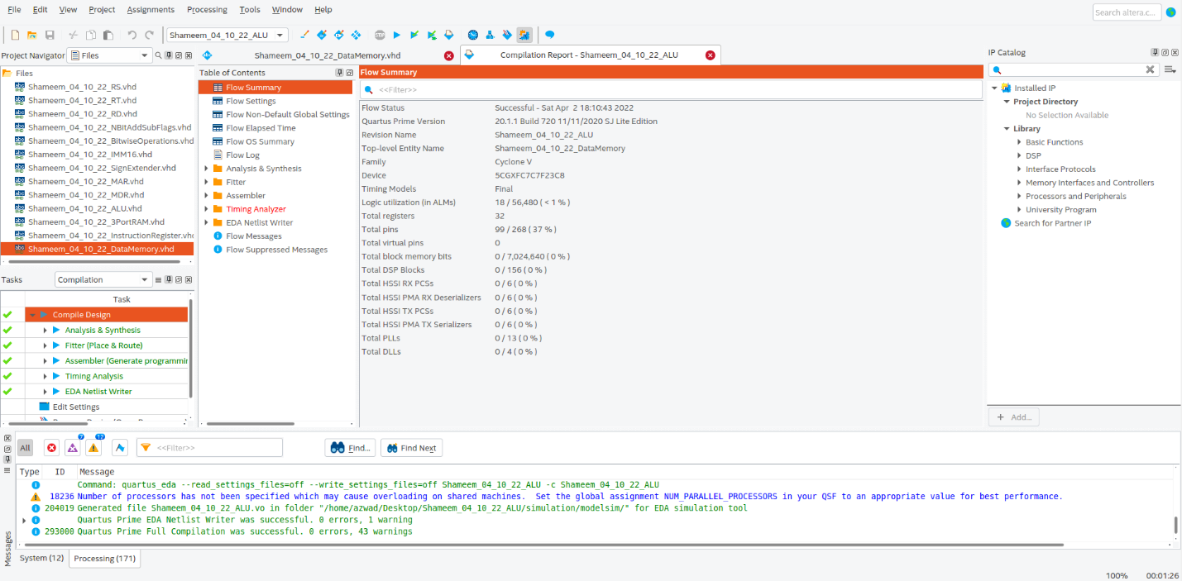Figure 49: Data Memory compilation report.

## Simulation:

### Part I.A

#### Add

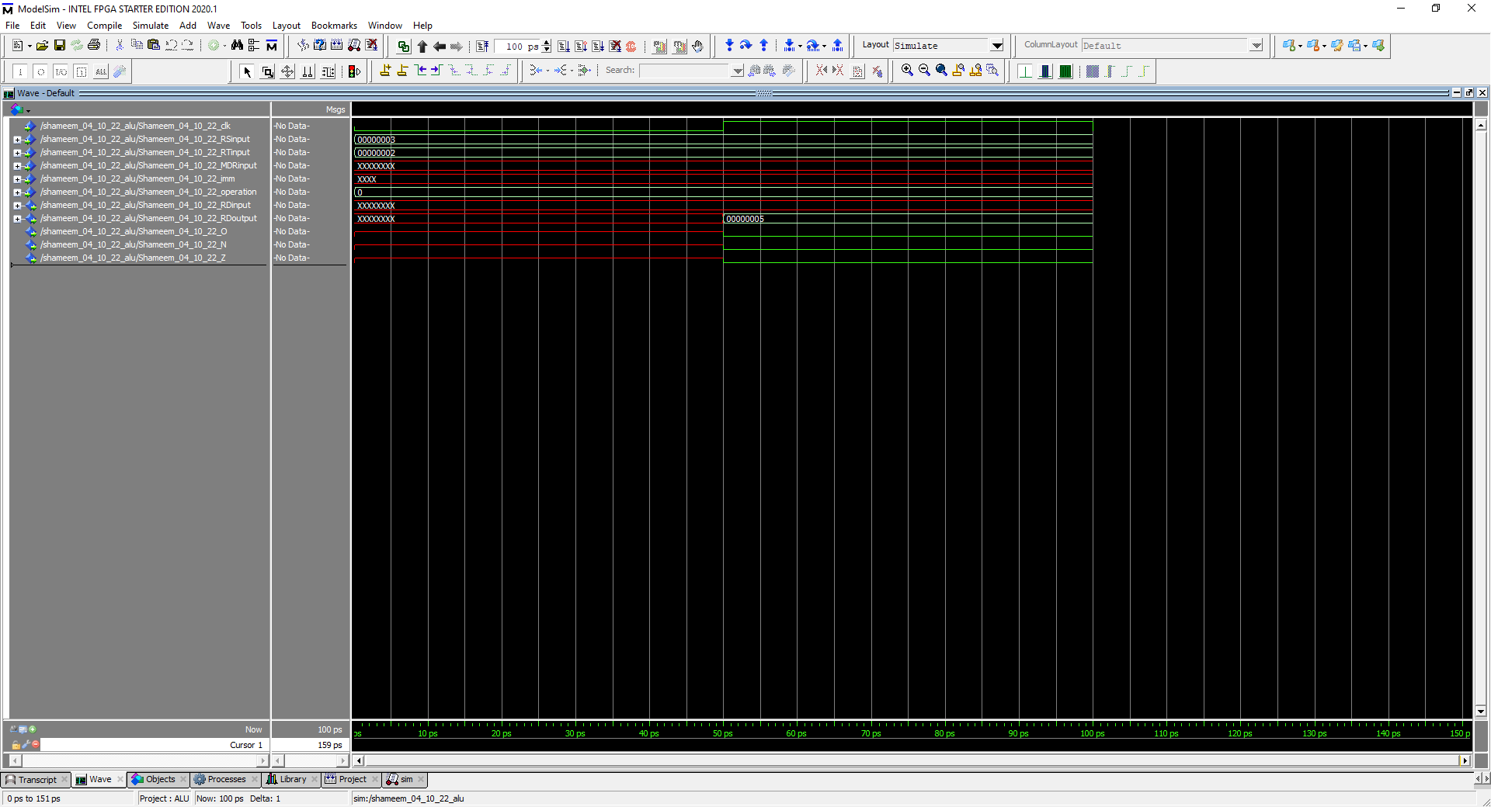

Figure 50: Simulation to represent ADD (radix is hexadecimal for everything)

In this simulation the operation is 0000 which stands for add so it takes RS and RT and adds them together and outputs them in the RD. Furthermore, 0x00000003 plus 0x00000002 equals 0x00000005, which means the flags zero and negative should be 0 as shown in the waveform because the output is clearly not negative or zero. The overflow flag is also 0 because the output does not trigger the rules of overflow since a positive plus a positive can equal a positive without any overflow.

R [rd] (0x00000005) = R[rs] (0x00000003) + R[rt] (0x00000002)

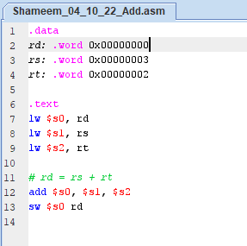

Figure 51: MIPS code for Add

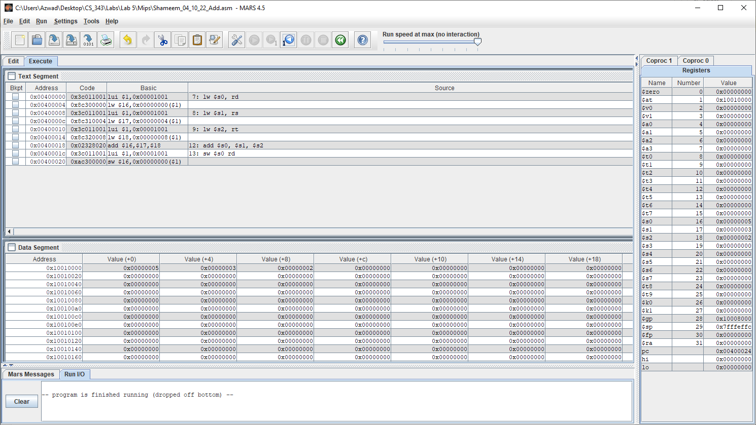

Figure 52: Executed Successfully.

Values RD, RS, RT shown clearly in data segment in the order of 0x00000005, 0x00000003, 0x00000002. The results of the MIPS code on MARS resulted in the same result as on the waveform simulation in figure 50. Therefore, add is the same on MARS and ModelSim waveform, so the VHDL code for add is working correctly.

#### Addu

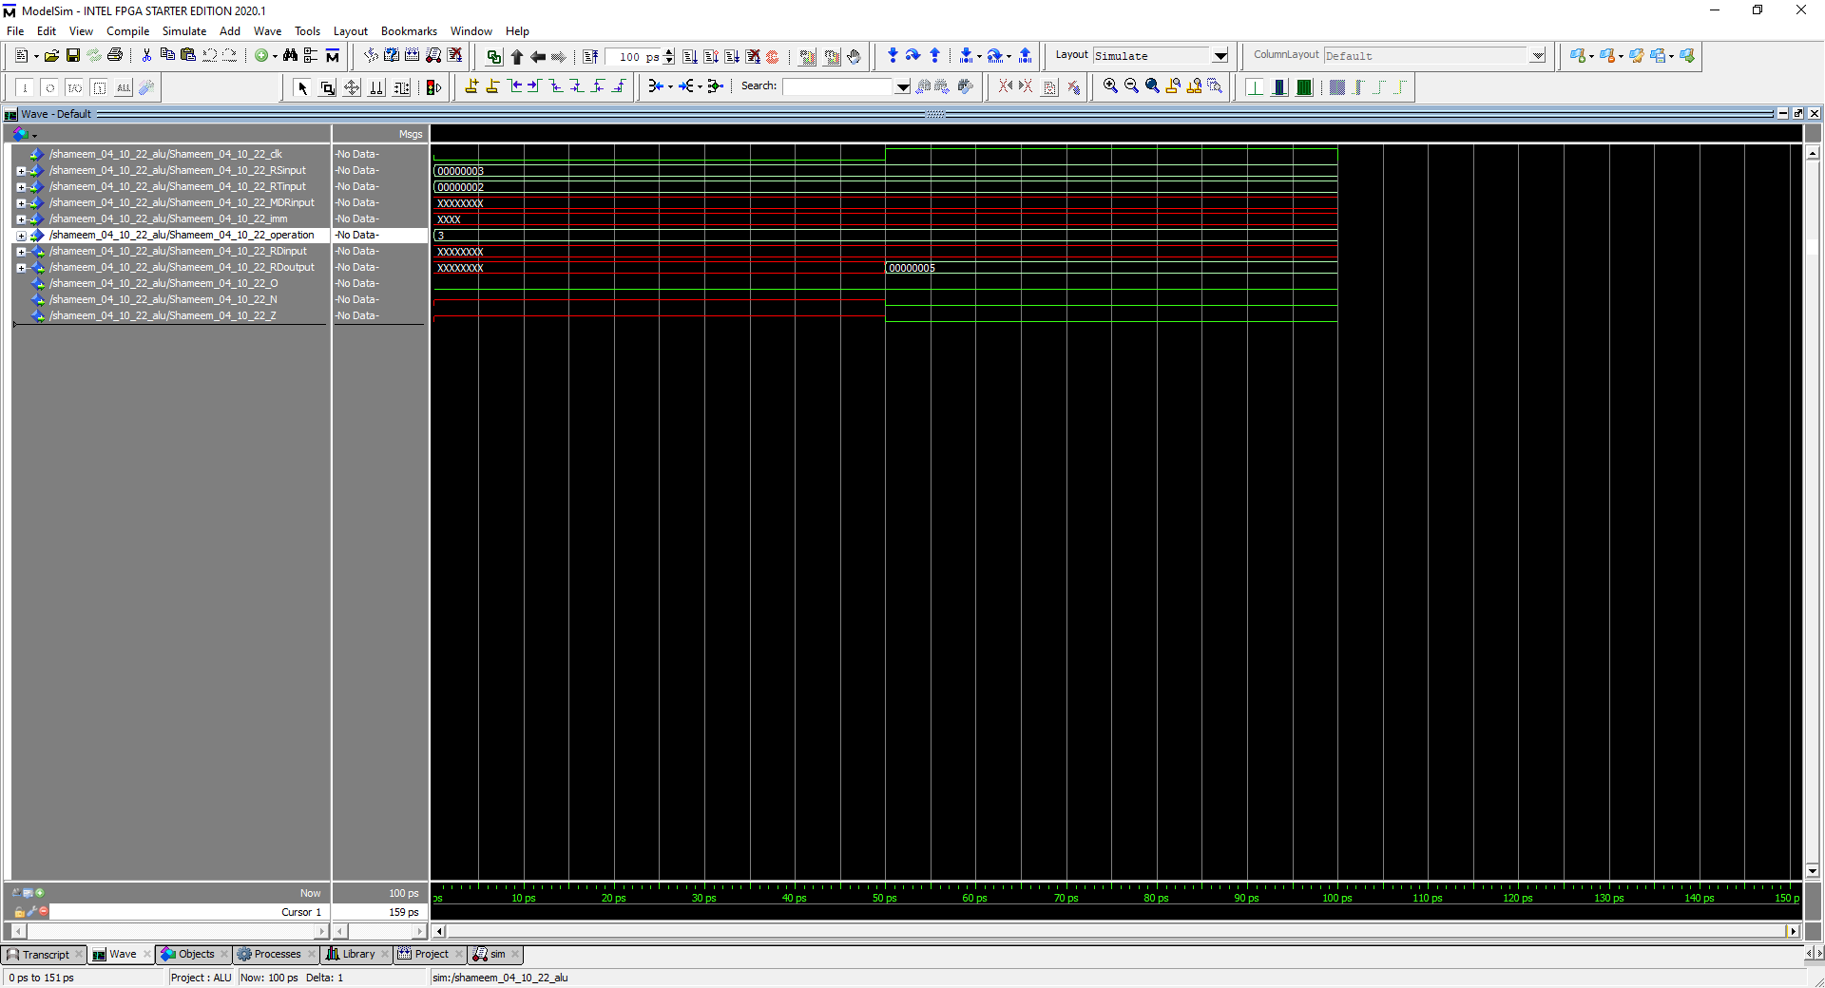

Figure 53: Simulation to represent Addu (radix is hexadecimal for everything)

In this simulation the operation is 0011, which stands for addu, so it takes RS and RT and adds them together and outputs them in the RD. Furthermore, since the operation is doing addu the overflow flag is set to ‘0’ and will not be triggered.

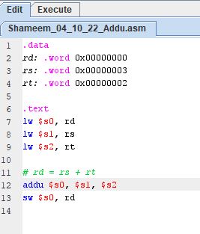

Figure 54: MIPS Addu

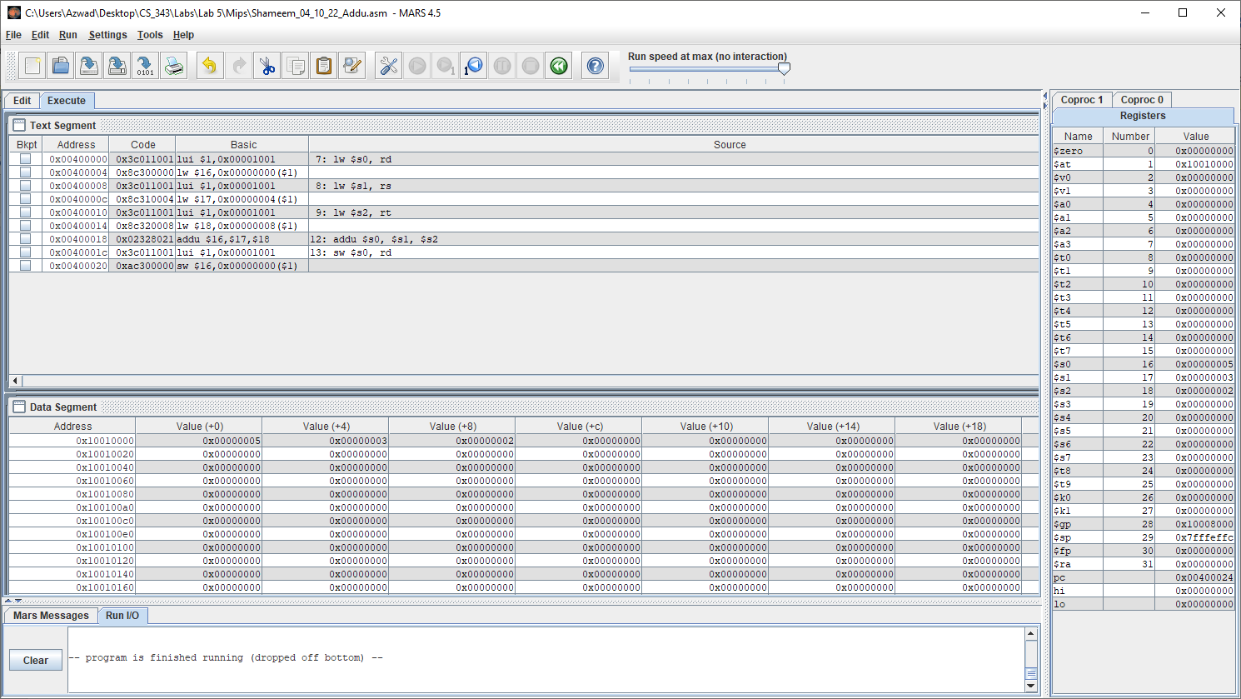

Figure 55: Executed Successfully in MARs.

Values RD, RS, RT from the equation RD = RS + RT shown clearly in data segment in the order of 0x00000005, 0x00000003, 0x00000002. The results of the MIPS code on MARS resulted in the same result as on the waveform simulation in figure 53. Therefore, addu is the same on MARS and ModelSim waveform, so the VHDL code for addu is working correctly.

#### Sub

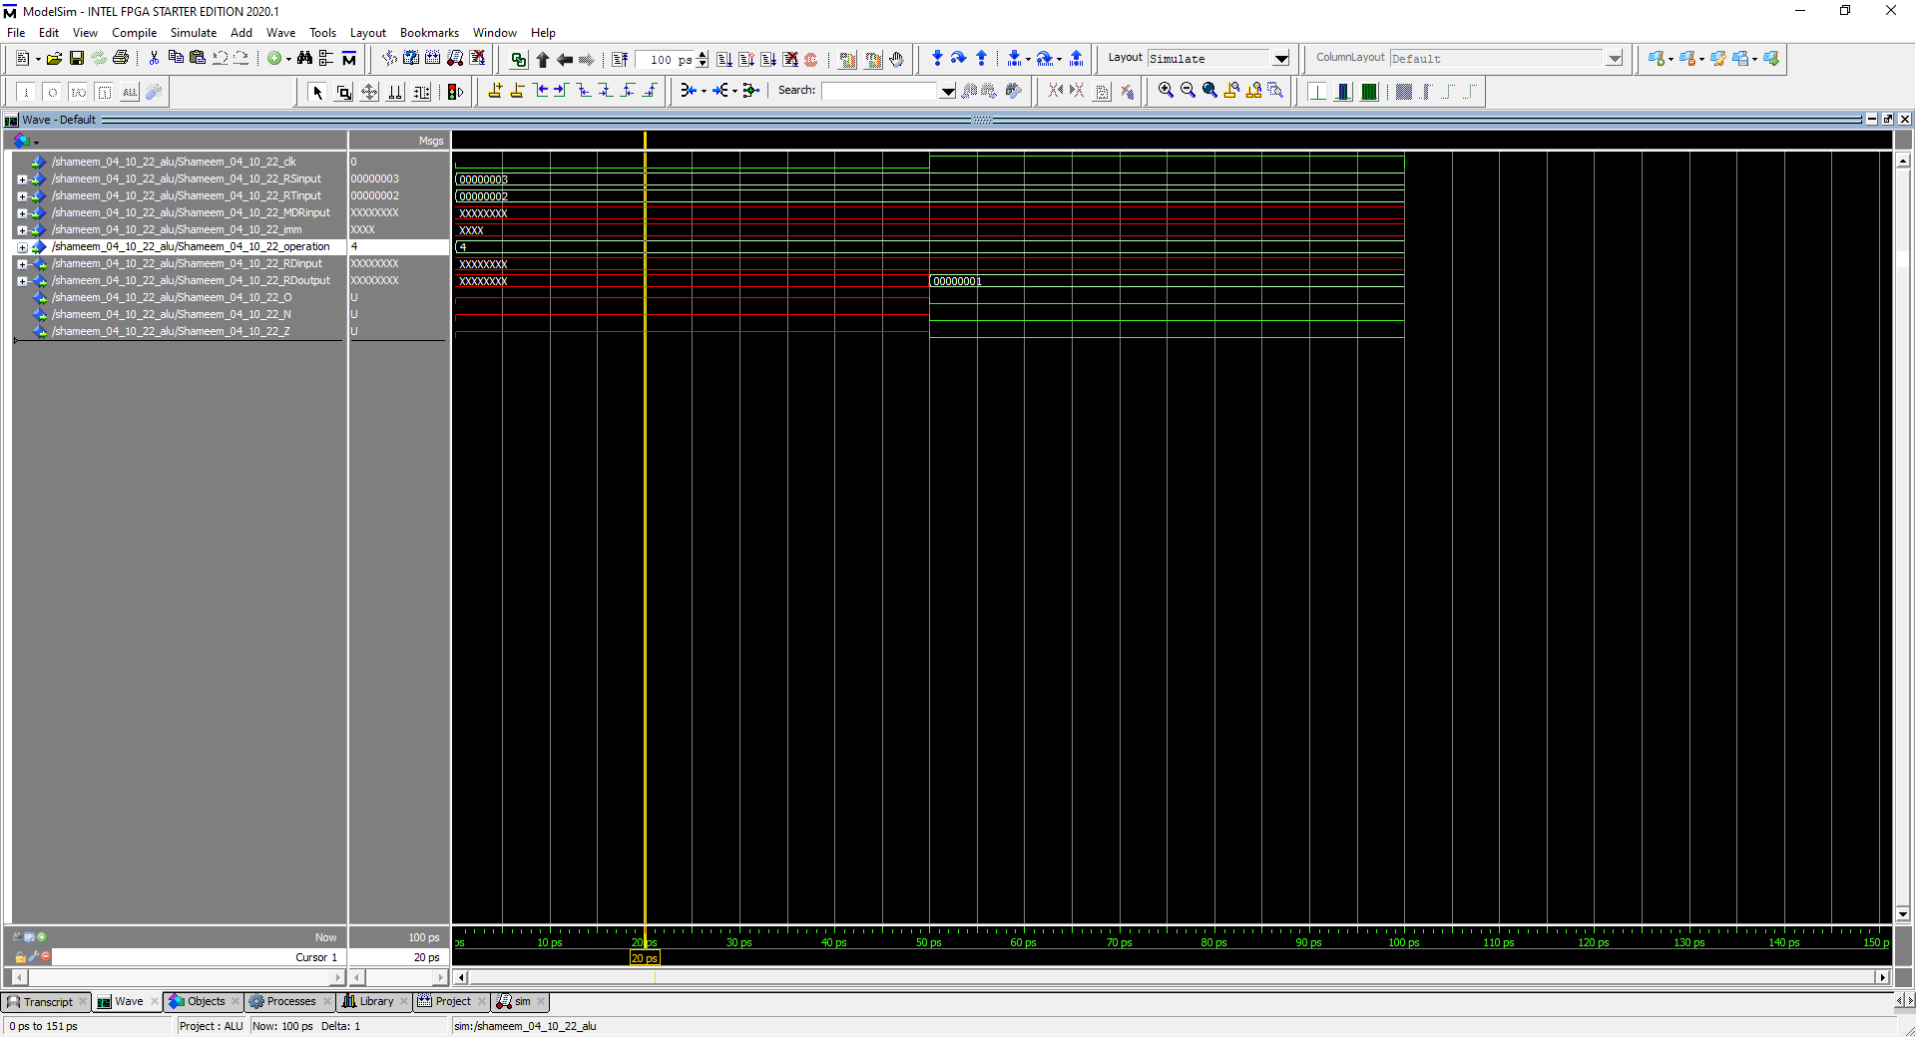

Figure 56: Simulation to represent Sub (radix is hexadecimal for everything)

In this simulation the operation is 0100 which stands for sub so it takes RS and RT and subtracts them and outputs them in the RD. Furthermore, 0x00000003 minus 0x00000002 equals 0x00000001, which means the flags zero and negative should be 0 as shown in the waveform because the output is clearly not negative or zero. The overflow flag is also 0 because the output does not trigger the rules of overflow since a positive minus a positive can equal a positive without any overflow.

R [rd] (0x00000001) = R[rs] (0x00000003) - R[rt] (0x00000002)

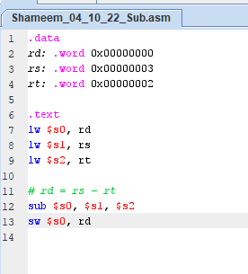

Figure 57: MIPS sub

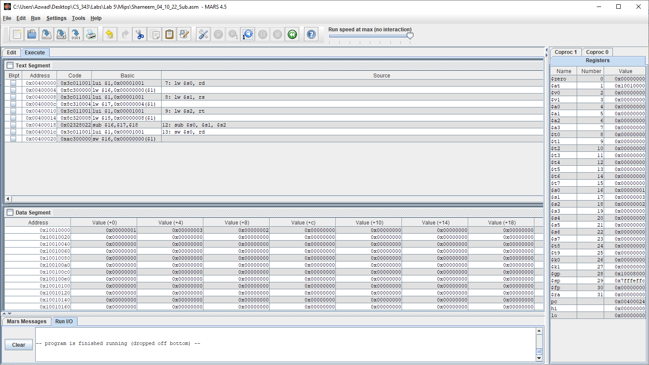

Figure 58: Executed Successfully on Mars.

Values RD, RS, RT shown clearly in data segment in the order of 0x00000001, 0x00000003, 0x00000002. The results of the MIPS code on MARS resulted in the same result as on the waveform simulation in figure 50. Therefore, sub is the same on MARS and ModelSim waveform, so the VHDL code for sub is working correctly.

#### Subu

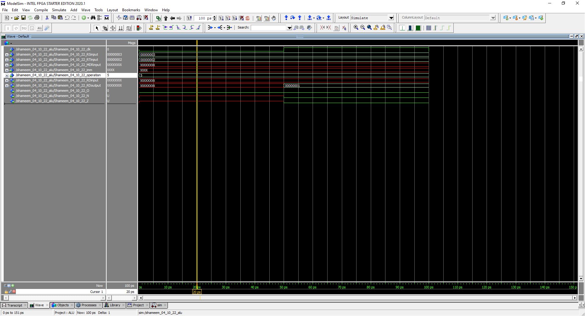

Figure 59: Simulation to represent Sub (radix is hexadecimal for everything)

In this simulation the operation is 0101 which stands for subu, so it takes RS and RT and subtracts them and outputs them in the RD. Furthermore, 0x00000003 minus 0x00000002 equals 0x00000001, which means the flags zero and negative should be 0 as shown in the waveform because the output is clearly not negative or zero. The overflow flag is also 0 because the output does not trigger the rules of overflow since a positive minus a positive can equal a positive without any overflow.

R [rd] (0x00000001) = R[rs] (0x00000003) - R[rt] (0x00000002)

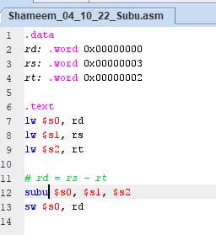

Figure 60: MIPS subu

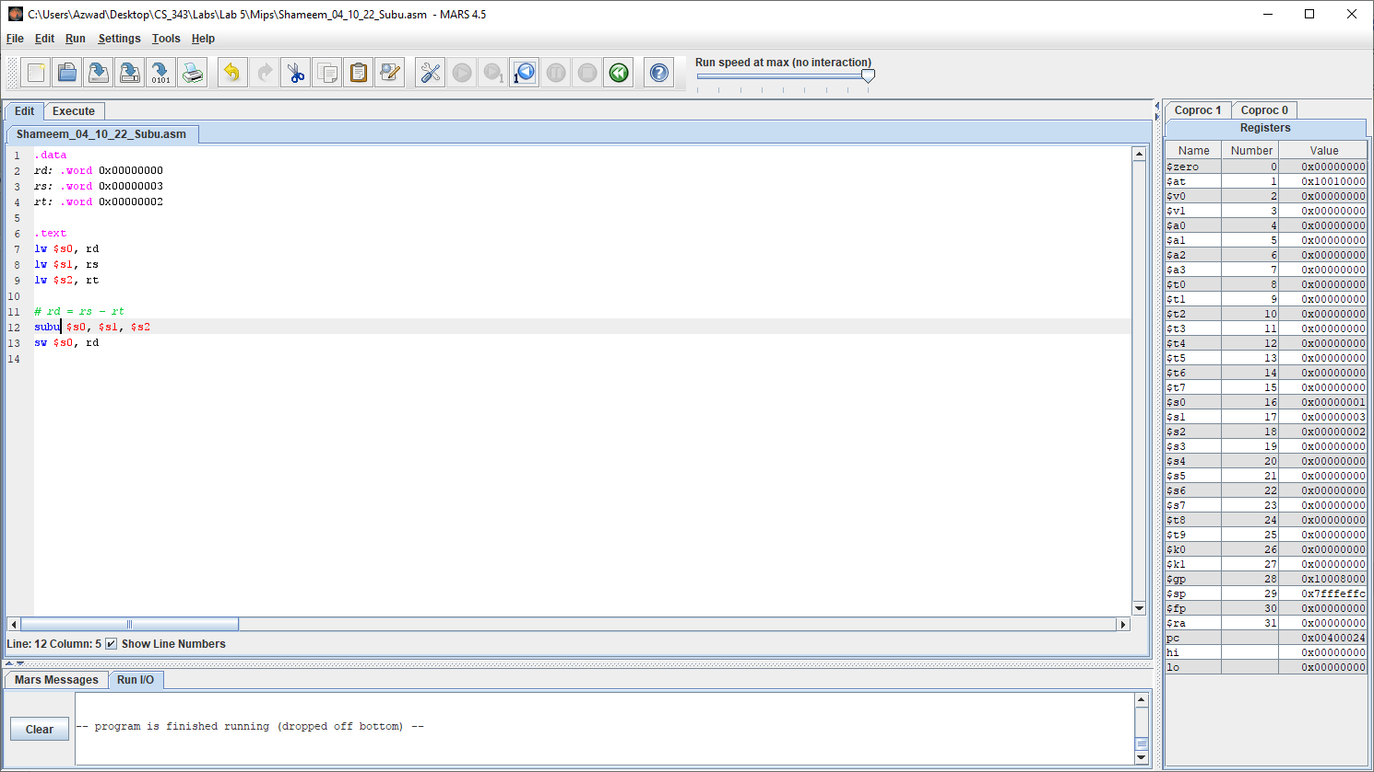

Figure 61: Executed Successfully on Mars.

Values RD, RS, RT shown clearly in data segment in the order of 0x00000001, 0x00000003, 0x00000002. The results of the MIPS code on MARS resulted in the same result as on the waveform simulation in figure 59. Therefore, subu is the same on MARS and ModelSim waveform, so the VHDL code for subu is working correctly.

#### And

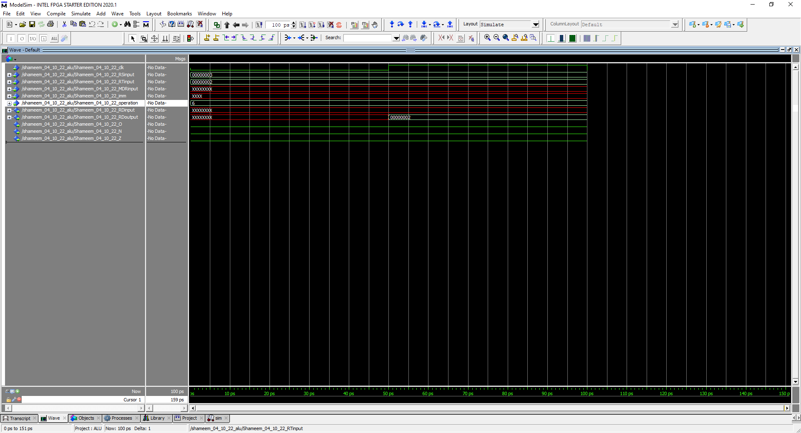

Figure 62: Simulation to represent AND (radix is hexadecimal for everything)

In this simulation the operation is 0110 which stands for add so it takes RS and RT and ands them, which outputs them in the RD. Furthermore, 0x00000003 and 0x00000002 equals 0x00000002, which means the flags zero and negative should be 0 as shown in the waveform because the output is clearly not negative or zero. The overflow flag is also 0 because and does not trigger an overflow.

R [rd] (0x00000002) = R[rs] (0x00000003) and R[rt] (0x00000002)

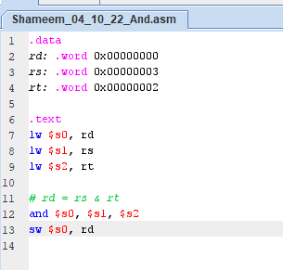

Figure 63: MIPS and

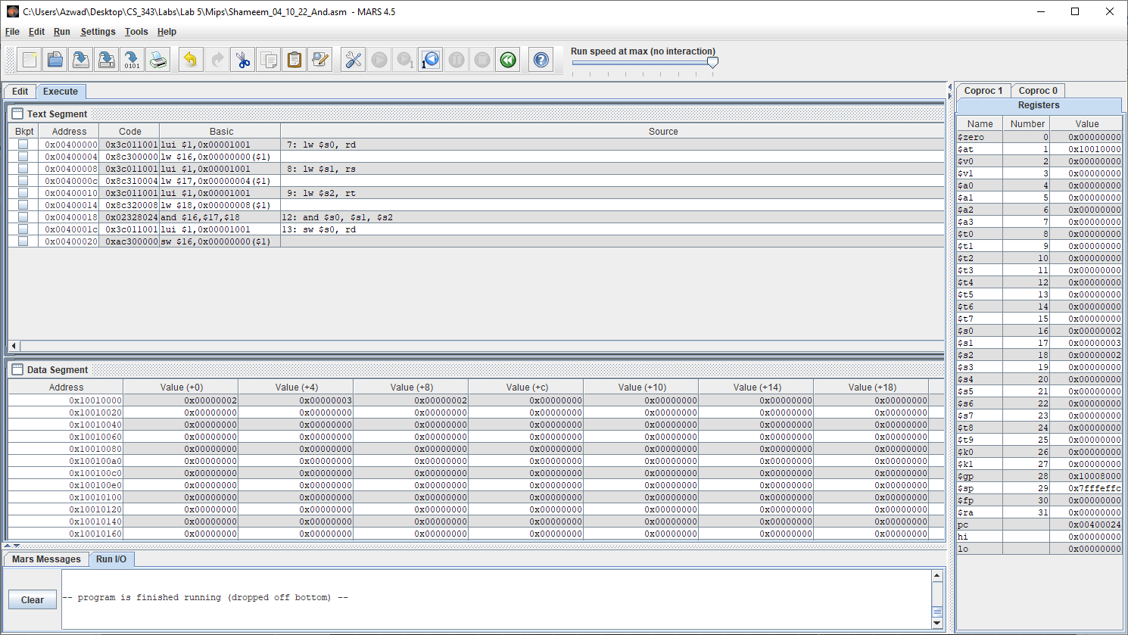

Figure 64: Successfully executed in MARs.

Values RD, RS, RT shown clearly in data segment in the order of 0x00000001, 0x00000003, 0x00000002. The results of the MIPS code on MARS resulted in the same result as on the waveform simulation in figure 62. Therefore, and is the same on MARS and ModelSim waveform, so the VHDL code for and is working correctly.

#### Nor

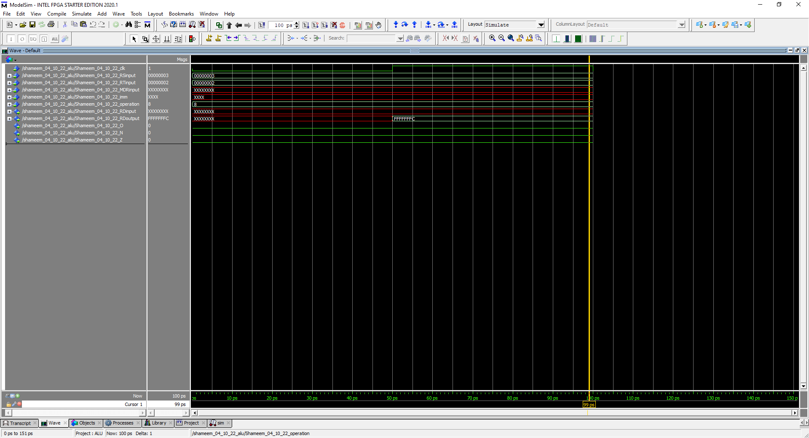

Figure 65: Simulation to represent AND (radix is hexadecimal for everything)

In this simulation the operation is 1000 which stands for add so it takes RS and RT and ands them, which outputs them in the RD. Furthermore, 0x00000003 and 0x00000002 equals 0xFFFFFFFC, which means the flags zero and negative should be 0 as shown in the waveform because the output is clearly not negative or zero. The overflow flag is also 0 because nor does not trigger an overflow.

R [rd] (0xFFFFFFFC) = R[rs] (0x00000003) nor R[rt] (0x00000002)

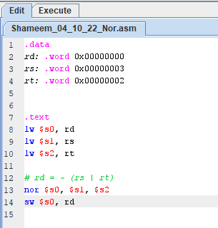

Figure 66: MIPS nor

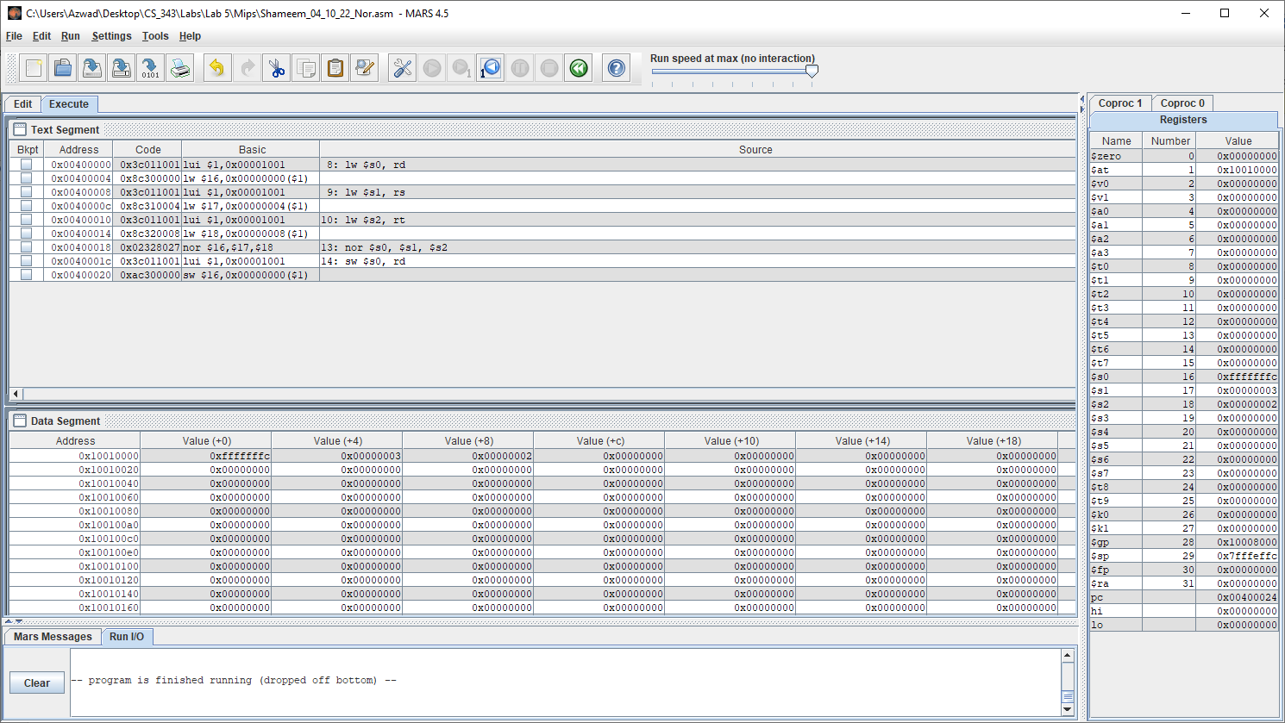

Figure 67: Successfully executed in MARs.

Values RD, RS, RT shown clearly in data segment in the order of 0xFFFFFFFC, 0x00000003, 0x00000002. The results of the MIPS code on MARS resulted in the same result as on the waveform simulation in figure 65. Therefore, nor is the same on MARS and ModelSim waveform, so the VHDL code for nor is working correctly.

#### OR

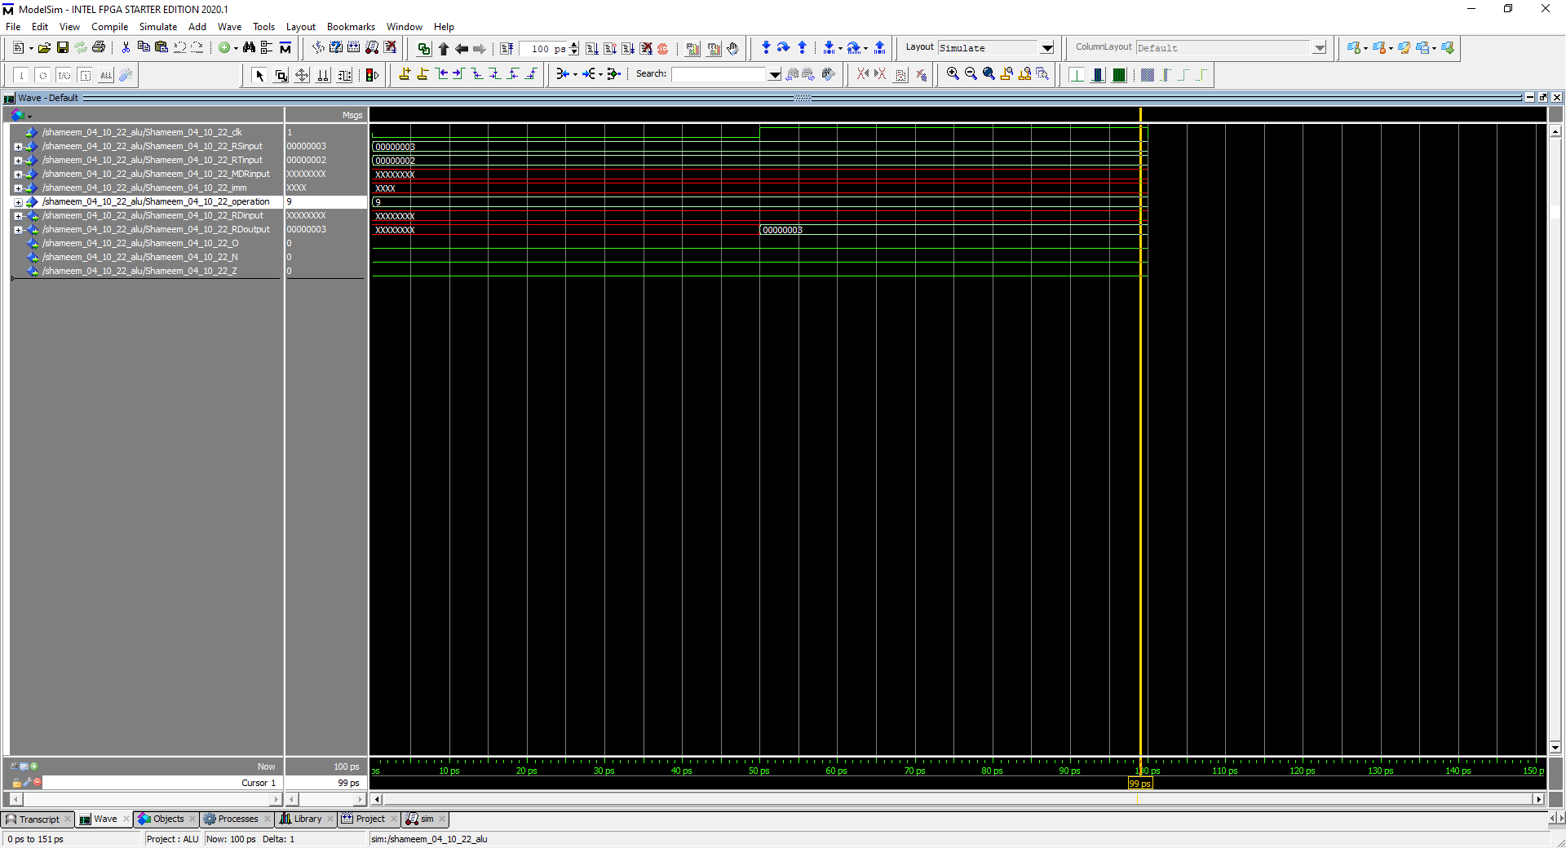

Figure 68: Simulation to represent AND (radix is hexadecimal for everything)

In this simulation the operation is 1001 which stands for add so it takes RS and RT and ands them, which outputs them in the RD. Furthermore, 0x00000003 and 0x00000002 equals 0x00000003, which means the flags zero and negative should be 0 as shown in the waveform because the output is clearly not negative or zero. The overflow flag is also 0 because or does not trigger an overflow.

R [rd] (0x00000003) = R[rs] (0x00000003) nor R[rt] (0x00000002)

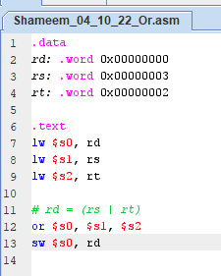

Figure 69: MIPS or

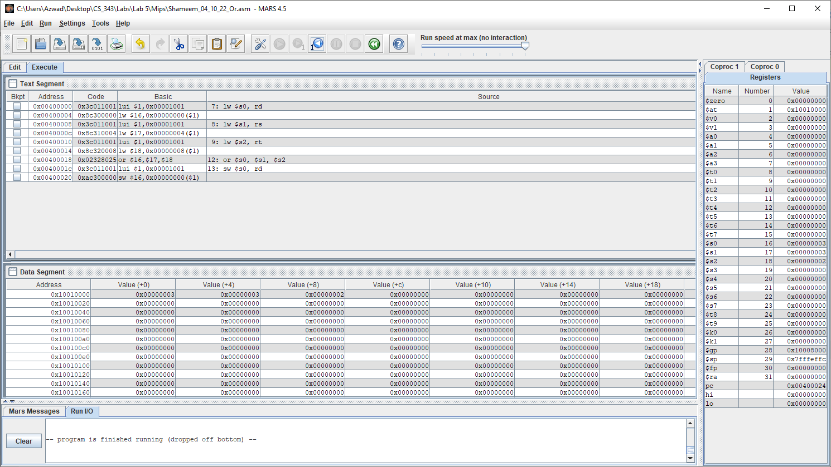

Figure 70: Executed successfully on MARs.

Values RD, RS, RT shown clearly in data segment in the order of 0x00000003, 0x00000003, 0x00000002. The results of the MIPS code on MARS resulted in the same result as on the waveform simulation in figure 62. Therefore, OR is the same on MARS and ModelSim waveform, so the VHDL code for OR is working correctly.

### Part I.B

#### Graphical user interface Description automatically generatedShift Left Logical – SLL

Figure 71: Simulation to represent SLL (radix is hexadecimal for everything)

R [rd] (0x00000004) = R[rt] (0x00000002) << shamt

In this simulation the operation is 1011 which stands for add so it takes RT and shifts it left by shamt, which then outputs in the RD. Furthermore, 0x00000002 shifted by shamt equals 0x00000004, which means the flags zero and negative should be 0 as shown in the waveform because the output is clearly not negative or zero. The overflow flag is also 0 because shifting does not trigger an overflow.

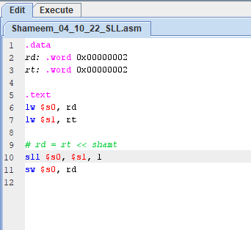

Figure 72: MIPS sll

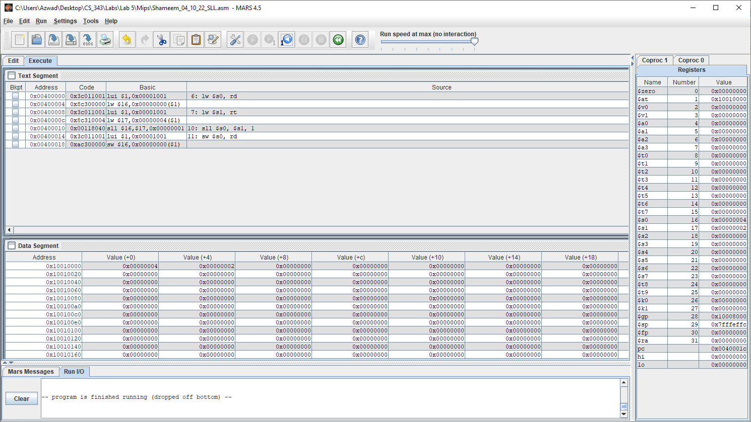

Figure 73: Executed successfully in MARs.

R [rd] (0x00000004) = R[rt] (0x00000002) << shamt

Values RD, RS shown clearly in data segment in the order of 0x00000004, 0x00000002. The results of the MIPS code on MARS resulted in the same result as on the waveform simulation in figure 71. Therefore, SLL is the same on MARS and ModelSim waveform, so the VHDL code for SLL is working correctly.

#### Shift Right Logical - SRL

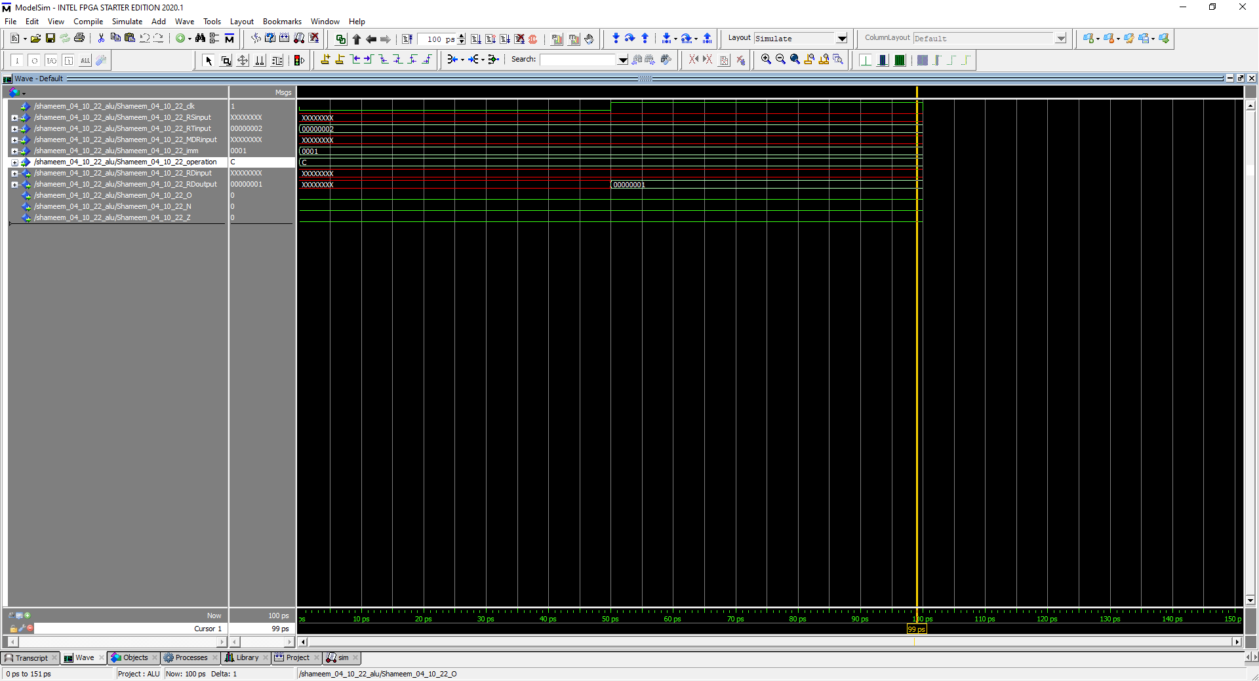

Figure 74: Simulation to represent SRL (radix is hexadecimal for everything)

R [rd] (0x00000001) = R[rt] (0x00000002) >> shamt

In this simulation the operation is 1100 which stands for add so it takes RT and shifts it left by shamt, which then outputs in the RD. Furthermore, 0x00000002 shifted by shamt equals 0x00000001, which means the flags zero and negative should be 0 as shown in the waveform because the output is clearly not negative or zero. The overflow flag is also 0 because shifting does not trigger an overflow.

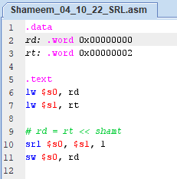

Figure 75: MIPS srl

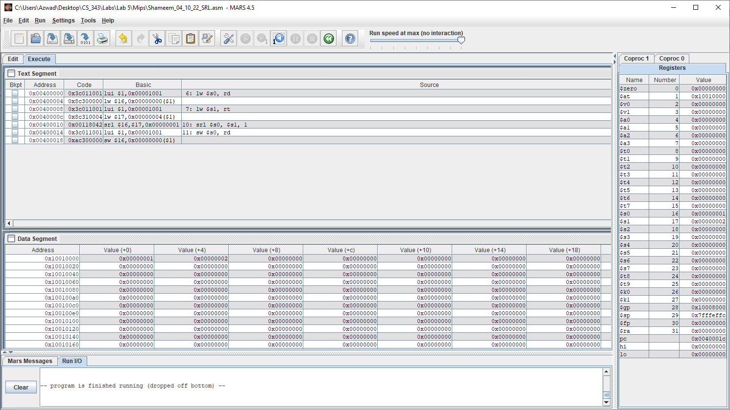

Figure 76: Executed successfully on MARs.

R [rd] (0x00000001) = R[rt] (0x00000002) >> shamt

Values RD, RS shown clearly in data segment in the order of 0x00000001, 0x00000002. The results of the MIPS code on MARS resulted in the same result as on the waveform simulation in figure 74. Therefore, SRL is the same on MARS and ModelSim waveform, so the VHDL code for SRL is working correctly.

#### Shift Left Arithmetic - SRA

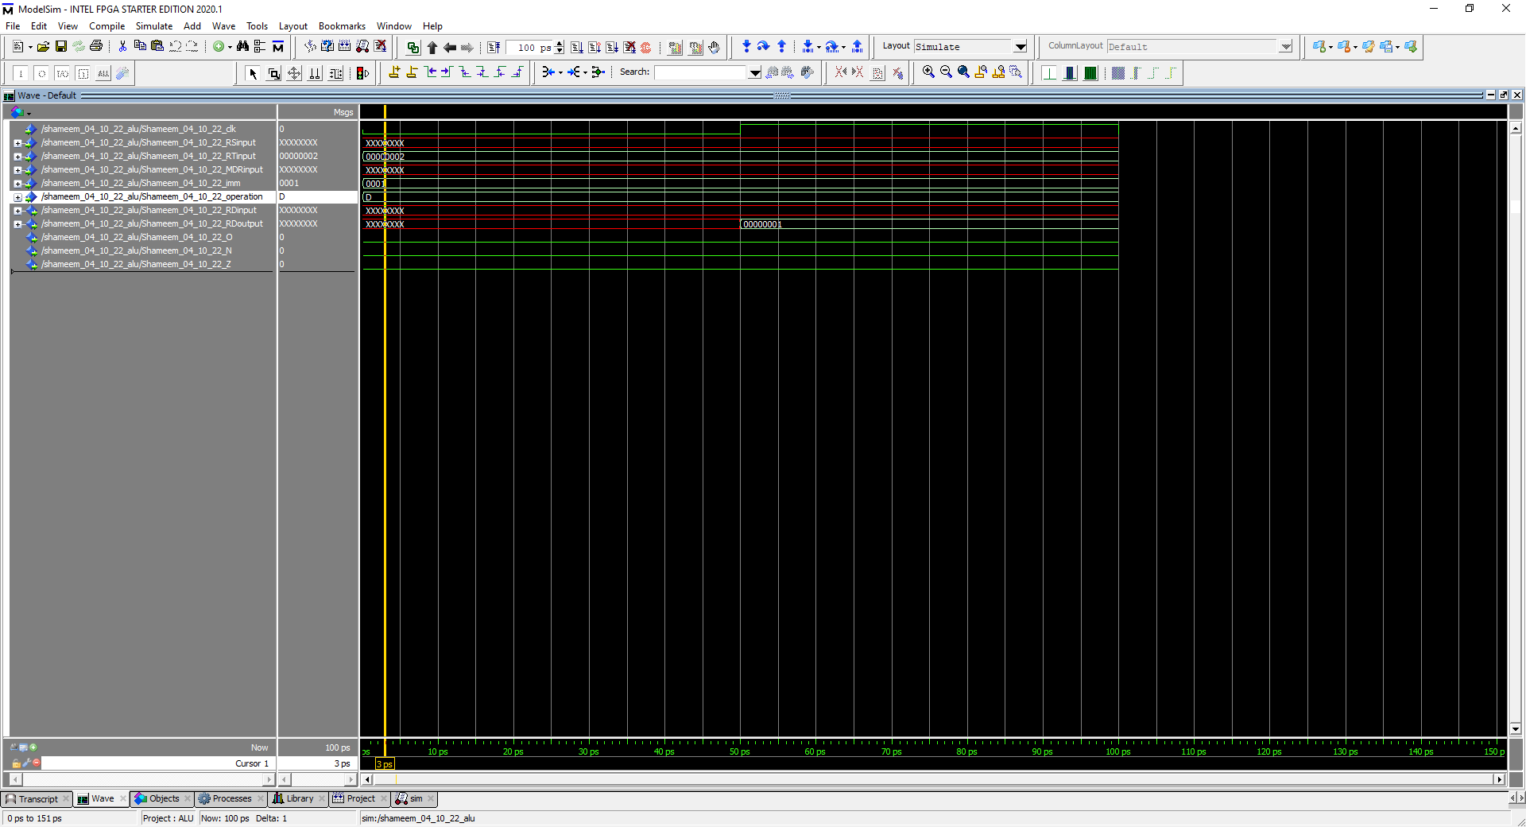

Figure 77: Simulation to represent SLL (radix is hexadecimal for everything)

R [rd] (0x00000001) = R[rt] (0x00000002) >>> shamt

In this simulation the operation is 1101 which stands for add so it takes RT and shifts it left by shamt, which then outputs in the RD. Furthermore, 0x00000002 shifted by shamt equals 0x00000001, which means the flags zero and negative should be 0 as shown in the waveform because the output is clearly not negative or zero. The overflow flag is also 0 because shifting does not trigger an overflow.

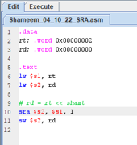

Figure 78: MIPS sra

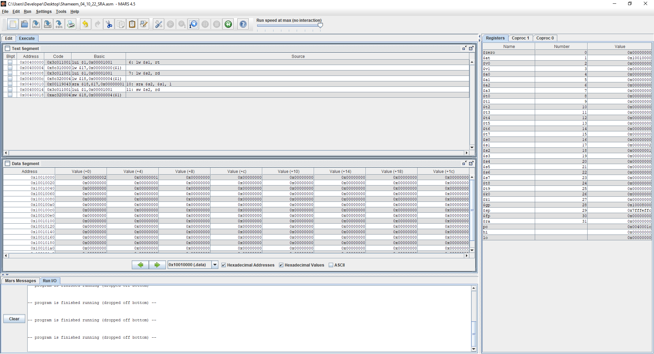

Figure 78: Executed successfully on MARs.

R [rd] (0x00000001) = R[rt] (0x00000002) >>> shamt

Values RS, RD shown clearly in data segment in the order of 0x00000002, 0x00000001. The results of the MIPS code on MARS resulted in the same result as on the waveform simulation in figure 76. Therefore, SRA is the same on MARS and ModelSim waveform, so the VHDL code for SRA is working correctly.

### Part II

#### Addi

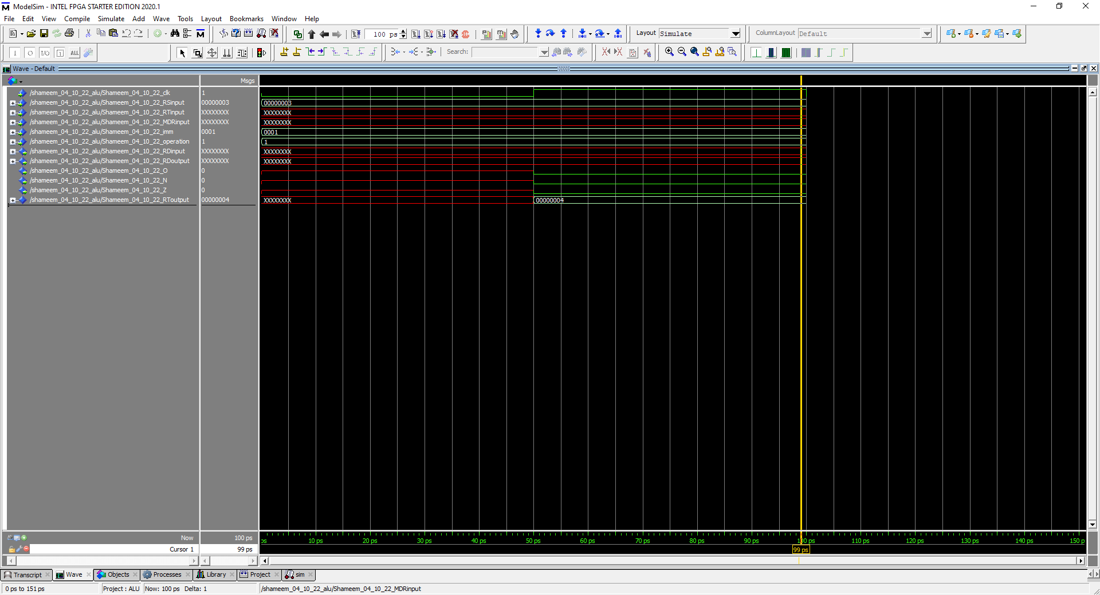

Figure 79: Simulation to represent Addi (radix is hexadecimal for everything)

R [rt] (0x00000004) = R[rs] (0x00000003) + SignExtImm

In this simulation the operation is 0001 which stands for addi so it takes RS and ZeroExtImm and adds them together and outputs them in the RD. Furthermore, 0x00000003 plus 0x00000001 equals 0x00000004, which means the flags zero and negative should be 0 as shown in the waveform because the output is clearly not negative or zero. The overflow flag is also 0 because positive plus positive equals a positive does not trigger the overflow.

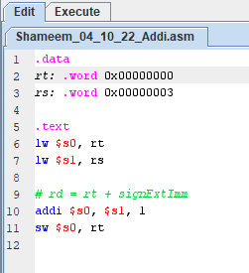

Figure 80: MIPS addi

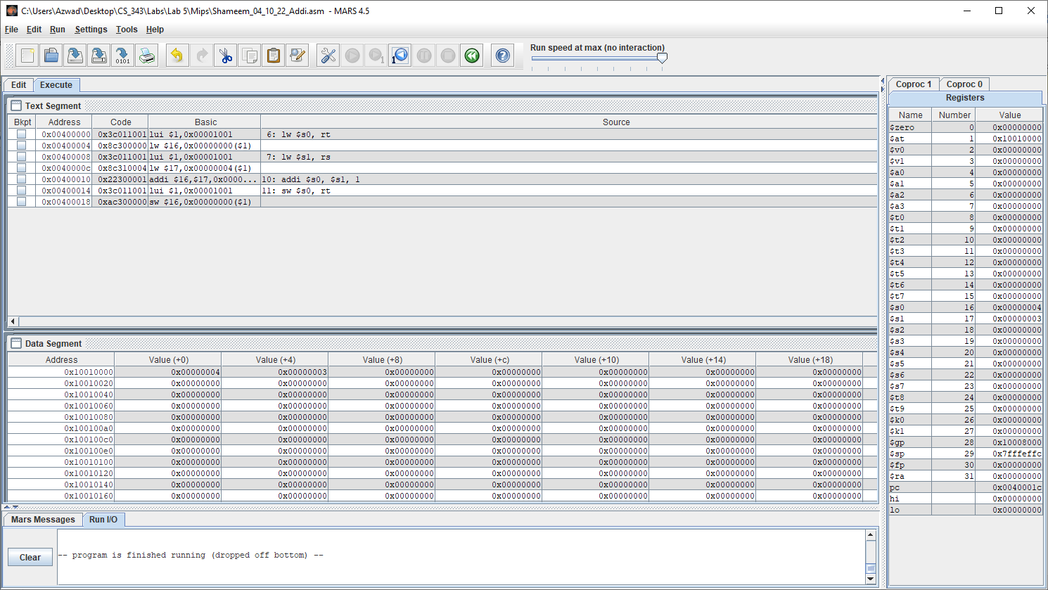

Figure 81: Executed successfully on MARs.

R [rt] (0x00000004) = R[rs] (0x00000003) + SignExtImm

Values RT, Rs shown clearly in data segment in the order of 0x00000004, 0x00000003. The results of the MIPS code on MARS resulted in the same result as on the waveform simulation in figure 79. Therefore, Addi is the same on MARS and ModelSim waveform, so the VHDL code for Addi is working correctly.

#### Addiu

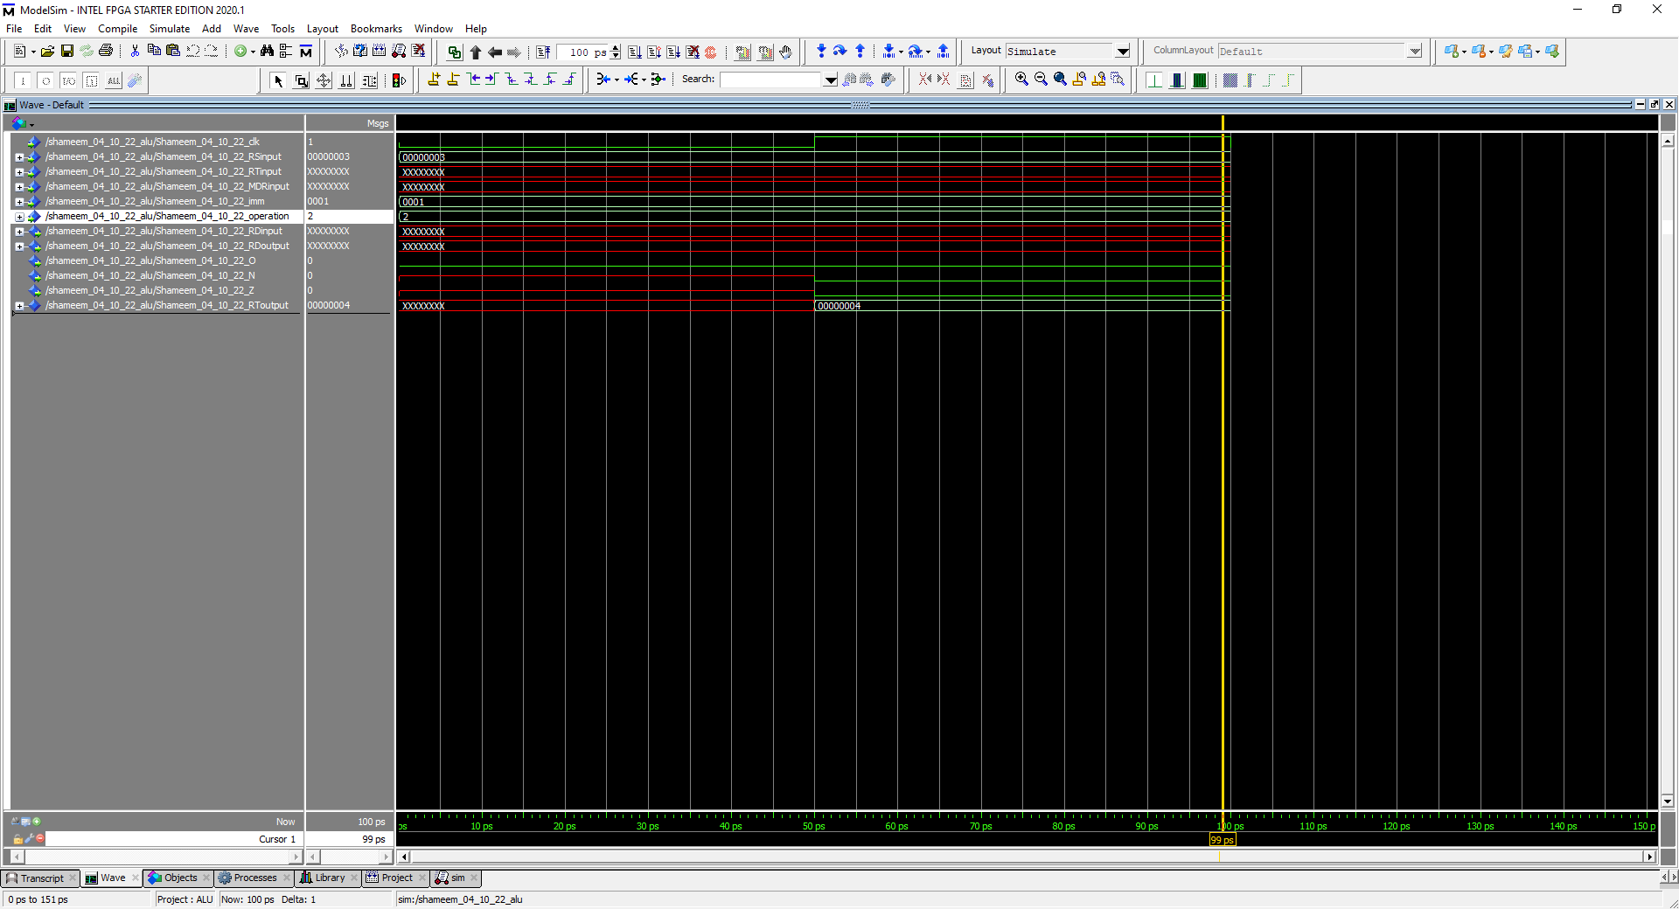

Figure 83: Simulation to represent Addiu (radix is hexadecimal for everything)

R [rt] (0x00000004) = R[rs] (0x00000003) + SignExtImm

In this simulation the operation is 0010 which stands for addiu, so it takes RS and ZeroExtImm and adds them together and outputs them in the RD. Furthermore, 0x00000003 plus 0x00000001 equals 0x00000004, which means the flags zero and negative should be 0 as shown in the waveform because the output is clearly not negative or zero. The overflow flag is also 0 because addiu does not detect overflows.

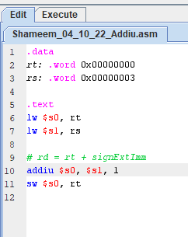

Figure 83: MIPS addiu

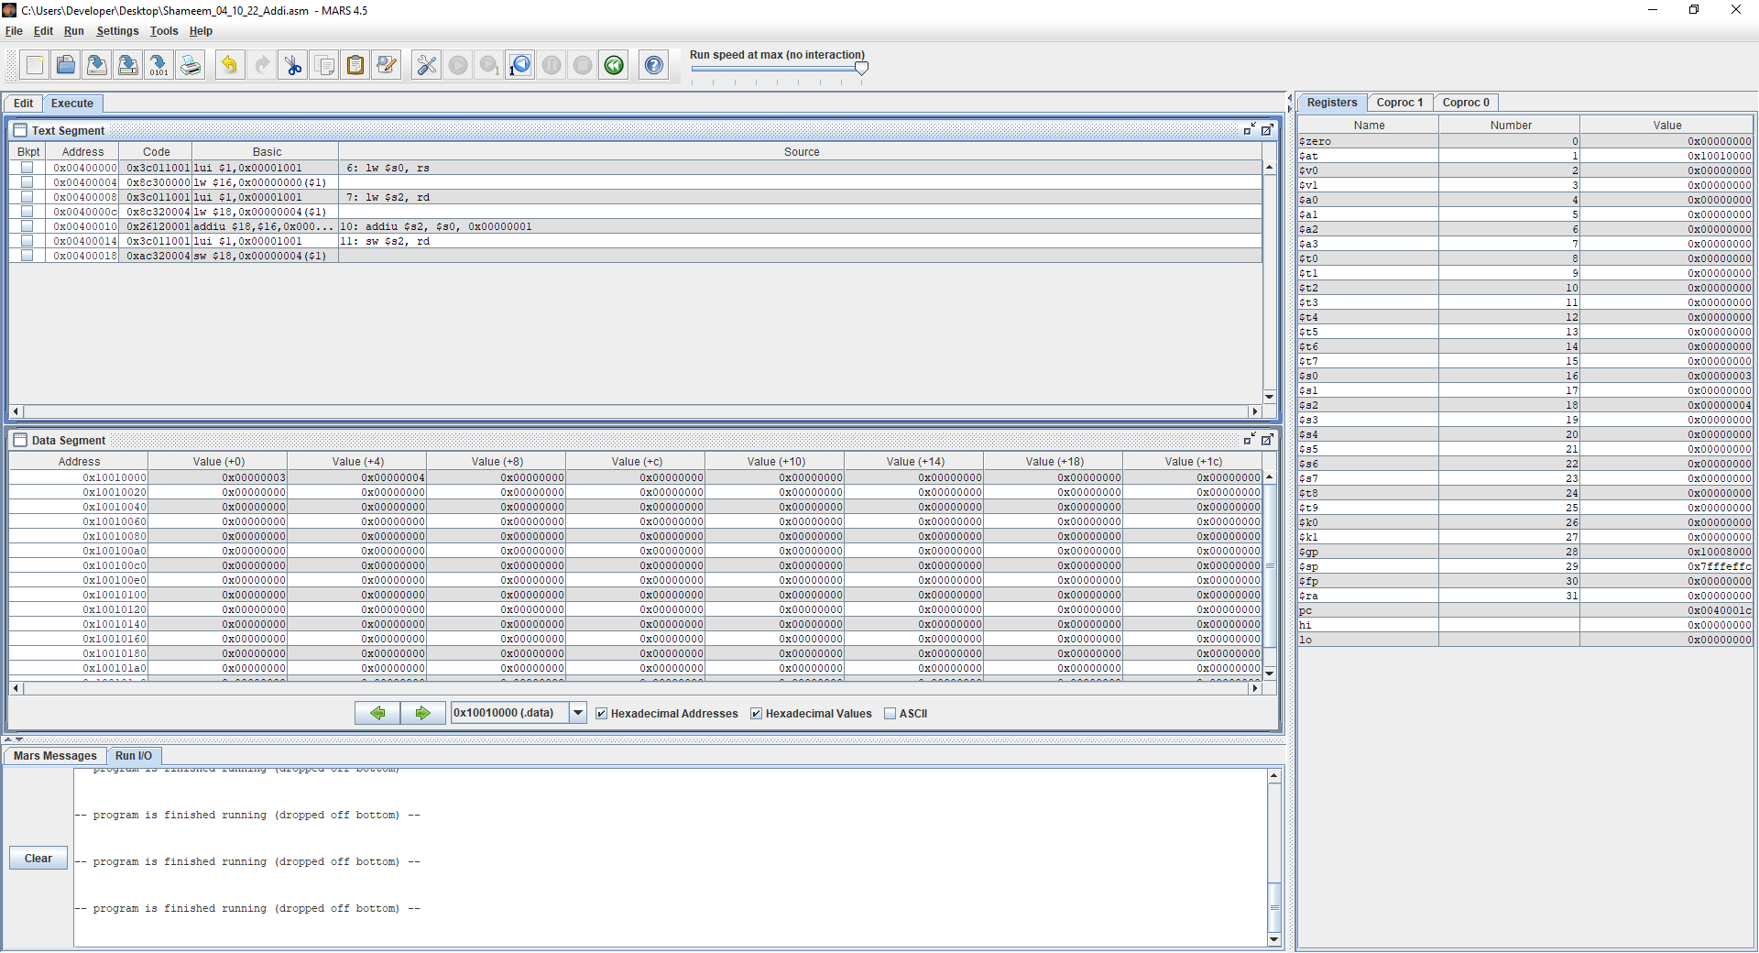

Figure 84: Executed successfully on MARs.

R [rt] (0x00000004) = R[rs] (0x00000003) + SignExtImm

Values RT, Rs shown clearly in data segment in the order of 0x00000004, 0x00000003. The results of the MIPS code on MARS resulted in the same result as on the waveform simulation in figure 79. Therefore, Addiu is the same on MARS and ModelSim waveform, so the VHDL code for Addiu is working correctly.

#### Andi

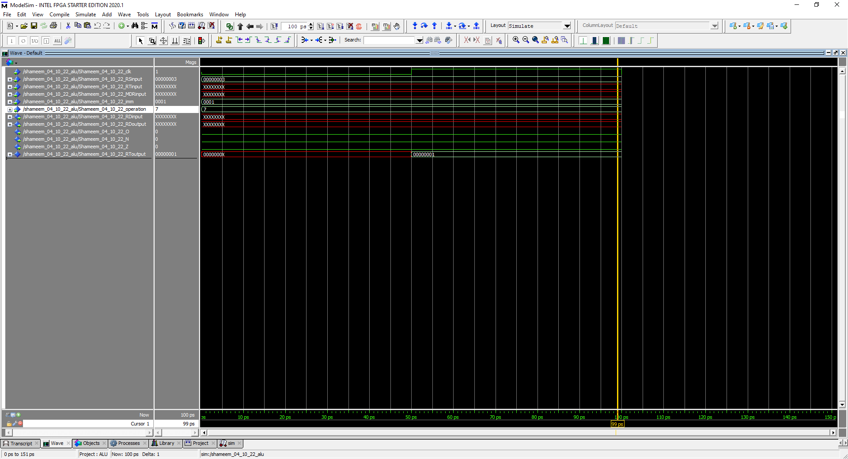

Figure 85: Simulation to represent Andi (radix is hexadecimal for everything)

R [rt] (0x00000001) = R[rs] (0x00000003) & ZeroExtImm

In this simulation the operation is 0111 which stands for andi, so it takes RS and RT and adds them together and outputs them in the RD. Furthermore, 0x00000003 & 0x00000001 equals 0x00000001, which means the flags zero and negative should be 0 as shown in the waveform because the output is clearly not negative or zero. The overflow flag is also 0 because andi does not trigger overflows.

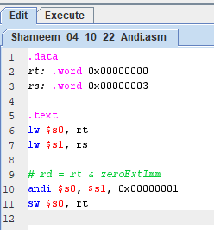

Figure 86: MIPS andi

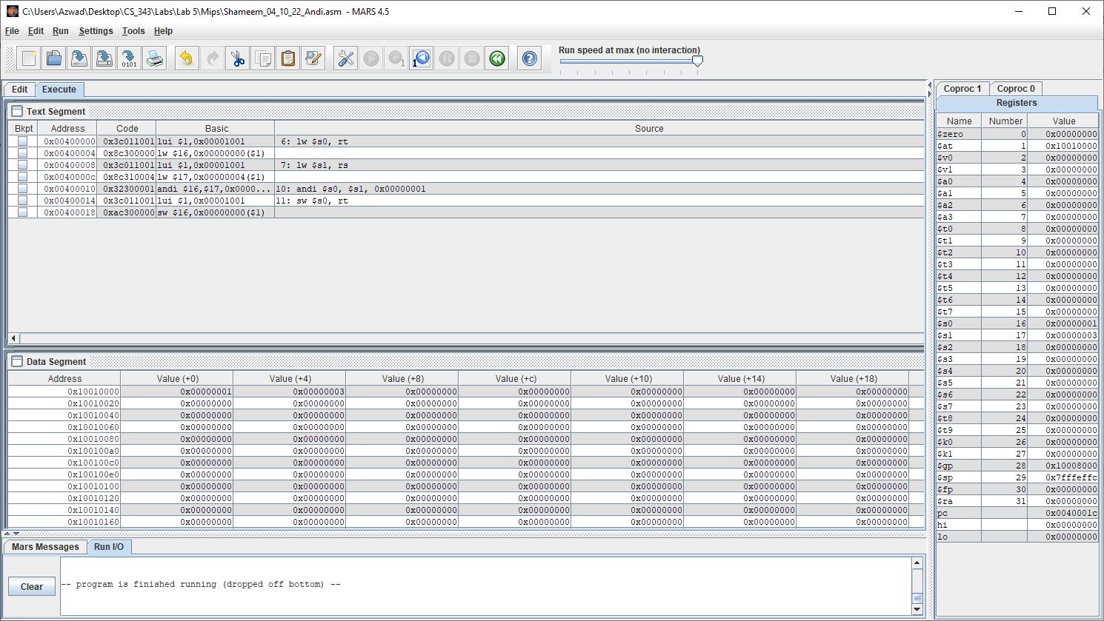

Figure 87: Executed successfully on MARs.

R [rt] (0x00000001) = R[rs] (0x00000003) & ZeroExtImm

Values RT, RS shown clearly in data segment in the order of 0x00000001, 0x00000003. The results of the MIPS code on MARS resulted in the same result as on the waveform simulation in figure 82. Therefore, Andi is the same on MARS and ModelSim waveform, so the VHDL code for Andi is working correctly.

#### Ori

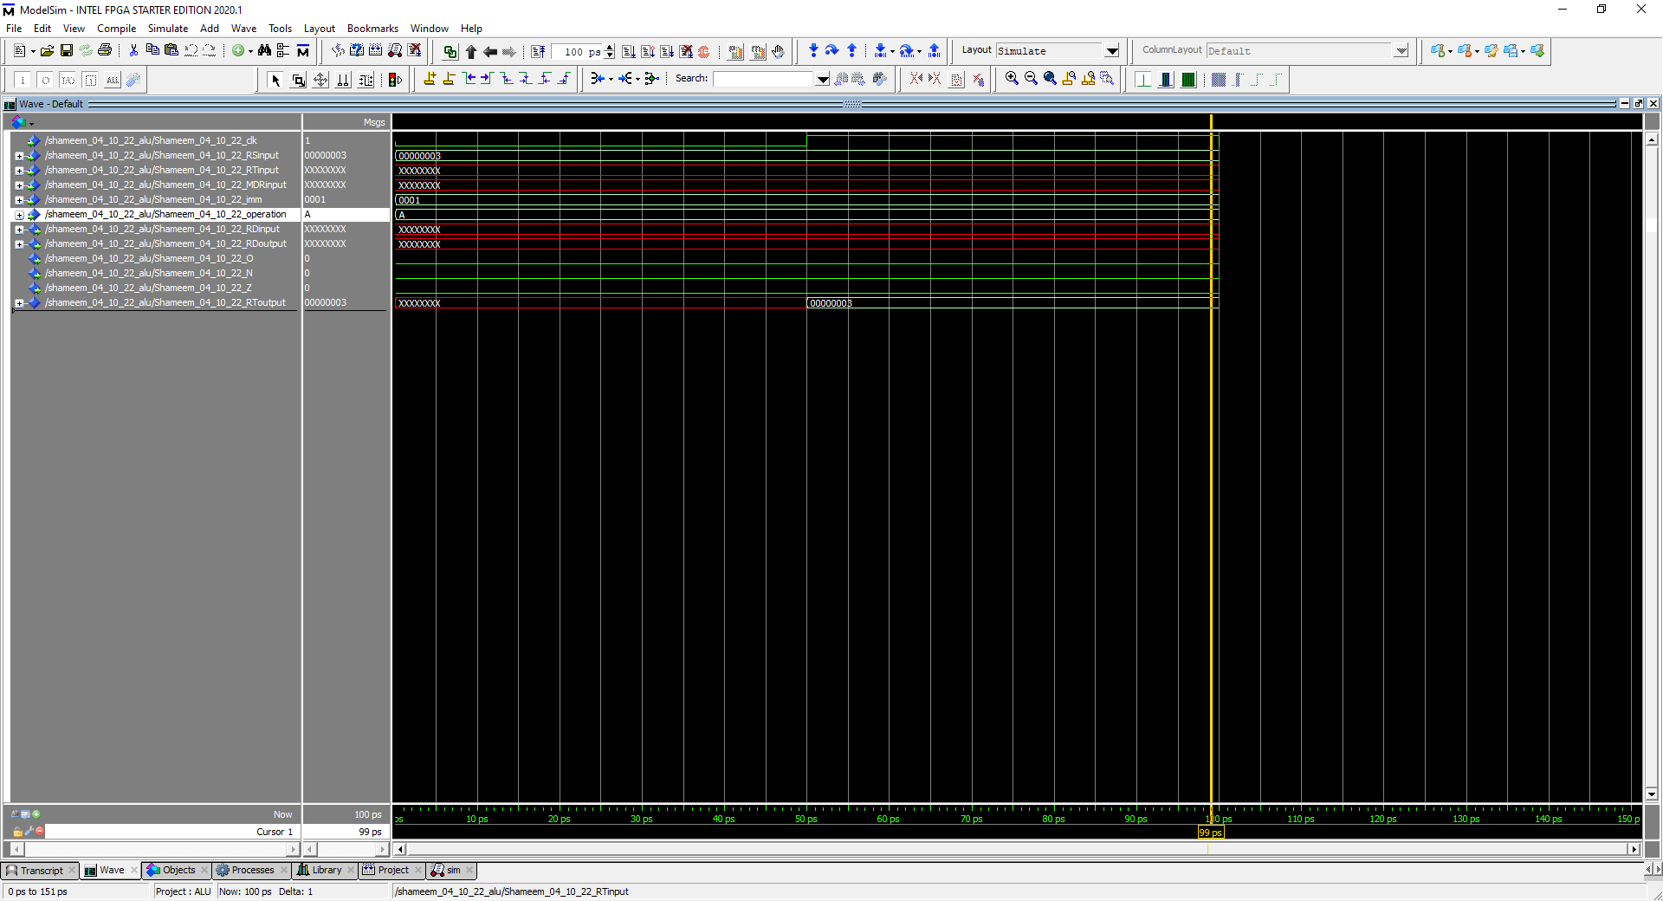

Figure 88: Simulation to represent Andi (radix is hexadecimal for everything)

R [rt] (0x00000003) = R[rs] (0x00000003) | ZeroExtImm

In this simulation the operation is 1010 which stands for Ori, so it takes RS and RT and adds them together and outputs them in the RD. Furthermore, 0x00000003 or 0x00000001 equals 0x00000003, which means the flags zero and negative should be 0 as shown in the waveform because the output is clearly not negative or zero. The overflow flag is also 0 because Ori does not trigger overflows.

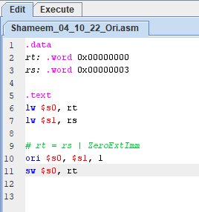

Figure 89: MIPS ori

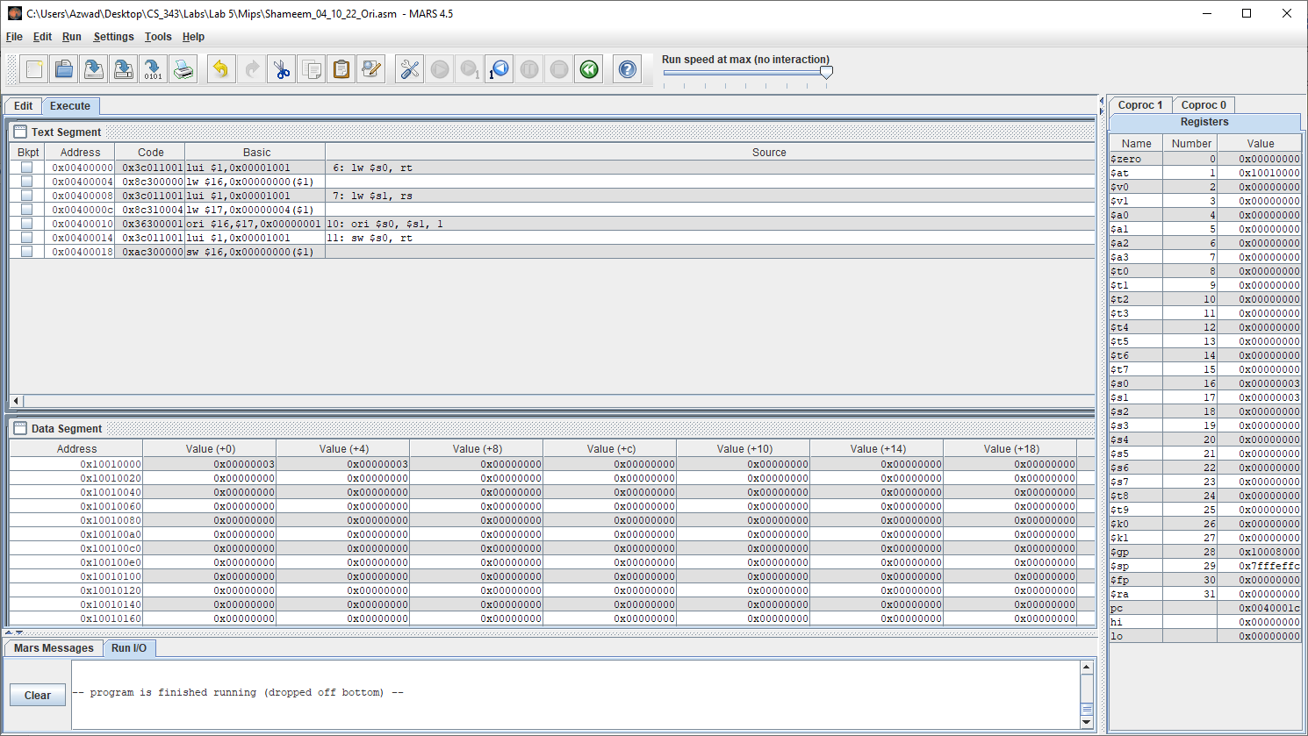

Figure 90: Executed successfully on MARs.

R [rt] (0x00000003) = R[rs] (0x00000003) | ZeroExtImm

Values RT, RS shown clearly in data segment in the order of 0x00000001, 0x00000003. The results of the MIPS code on MARS resulted in the same result as on the waveform simulation in figure 87. Therefore, Ori is the same on MARS and ModelSim waveform, so the VHDL code for Ori is working correctly.

### Part III

#### LW

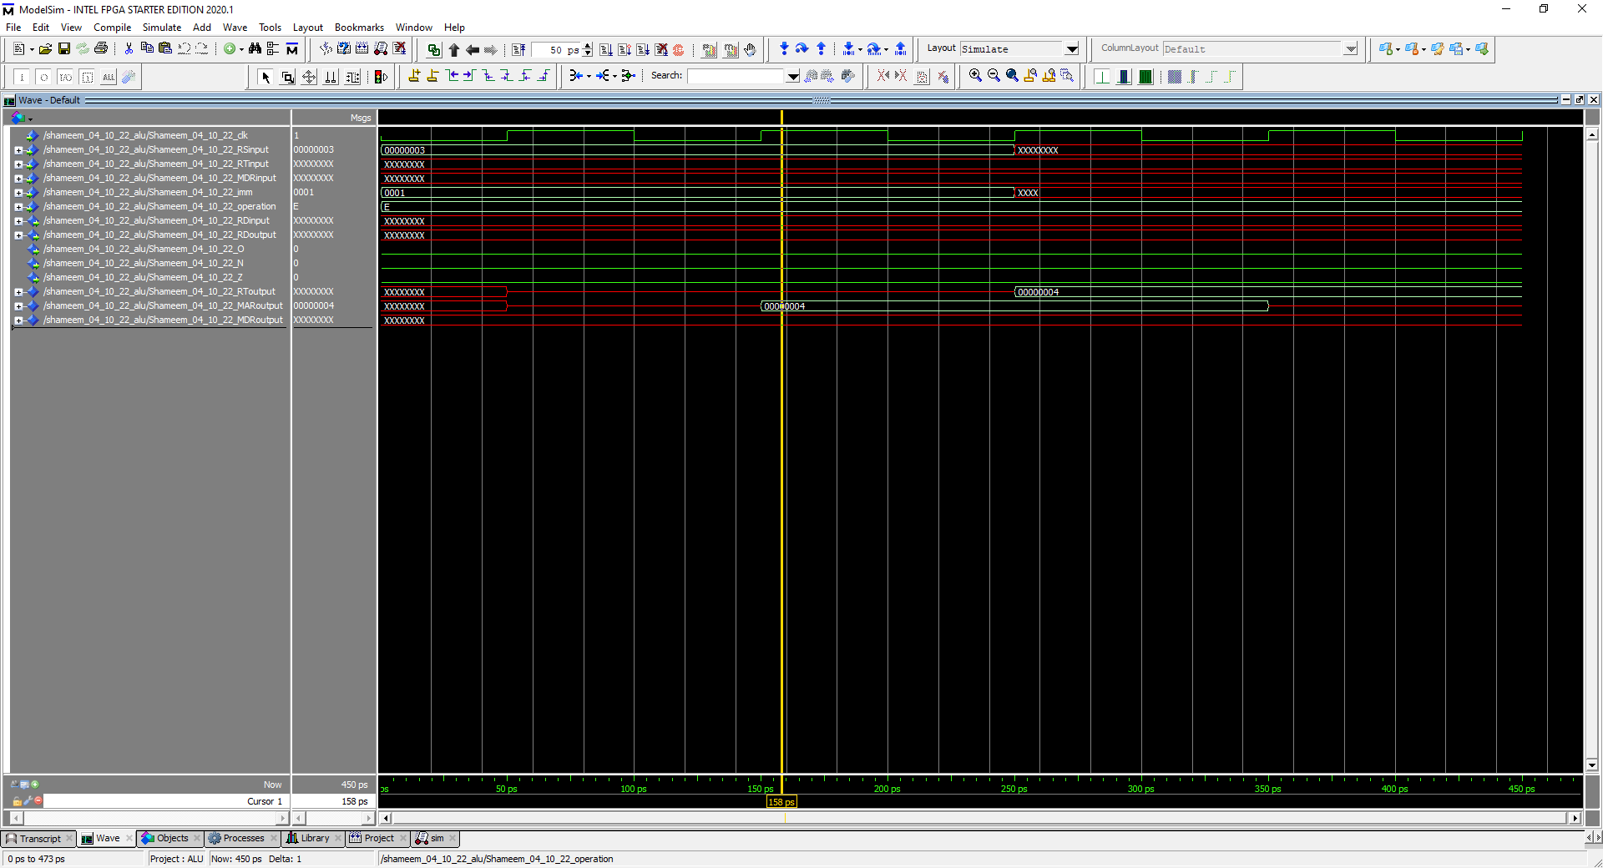

Figure 91: Simulation to represent LW (radix is hexadecimal for everything)

R [rt] (0x00000004) = M[R[rs] (0x00000003) + SignExtImm]

In this simulation the operation is 1111 which stands for LW, so it takes RS and SignExtImm and adds them together and outputs them into MAR which then goes into RT. Furthermore, 0x00000003 plus 0x00000001 equals 0x00000004, which means the flags zero and negative should be 0 as shown in the waveform because the output is clearly not negative or zero. The overflow flag is also 0 because the output does not trigger the rules of overflow since a positive plus a positive can equal a positive without any overflow.

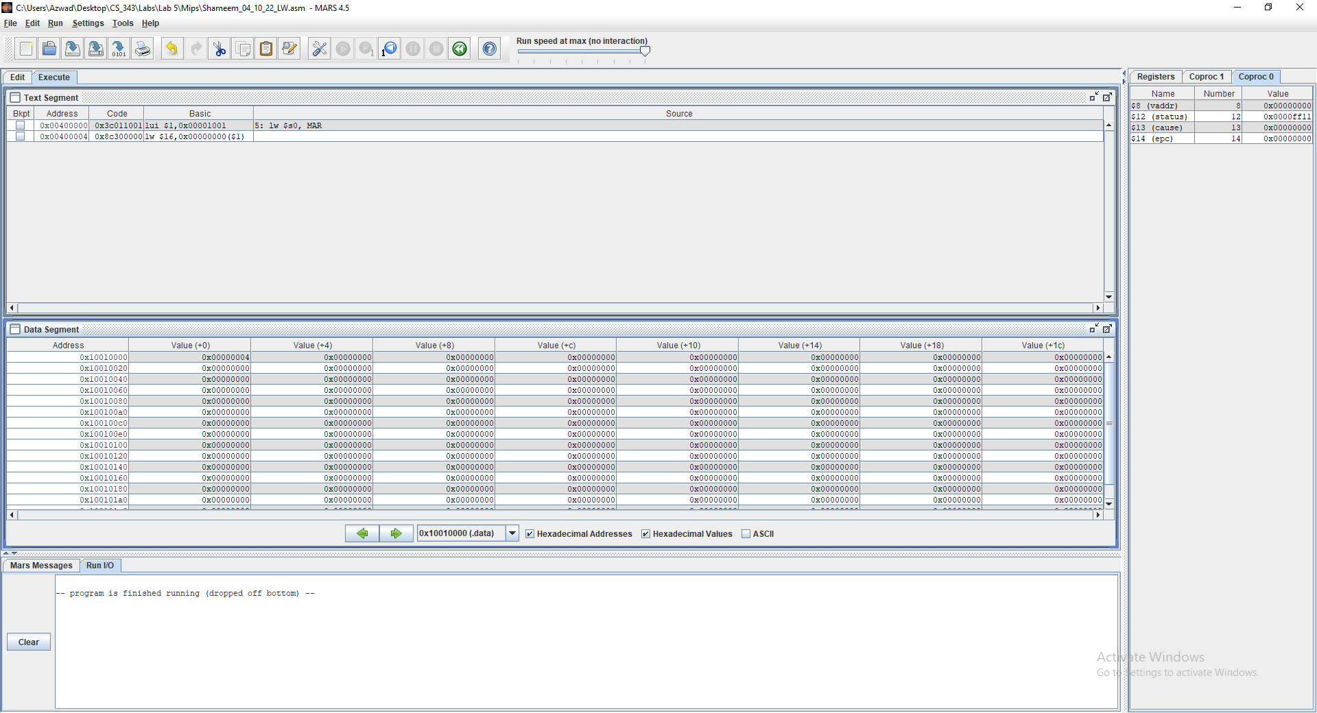

Figure 92: Executed successfully on MARs.

R [rt] (0x00000004) = M[R[rs] (0x00000003) + SignExtImm]

Values MAR shown clearly in data segment, which is 0x00000004. The results of the MIPS code on MARS resulted in the same result as on the waveform simulation in figure 91. Therefore, lw is the same on MARS and ModelSim waveform, so the VHDL code for lw is working correctly.

### Part IV

#### SW

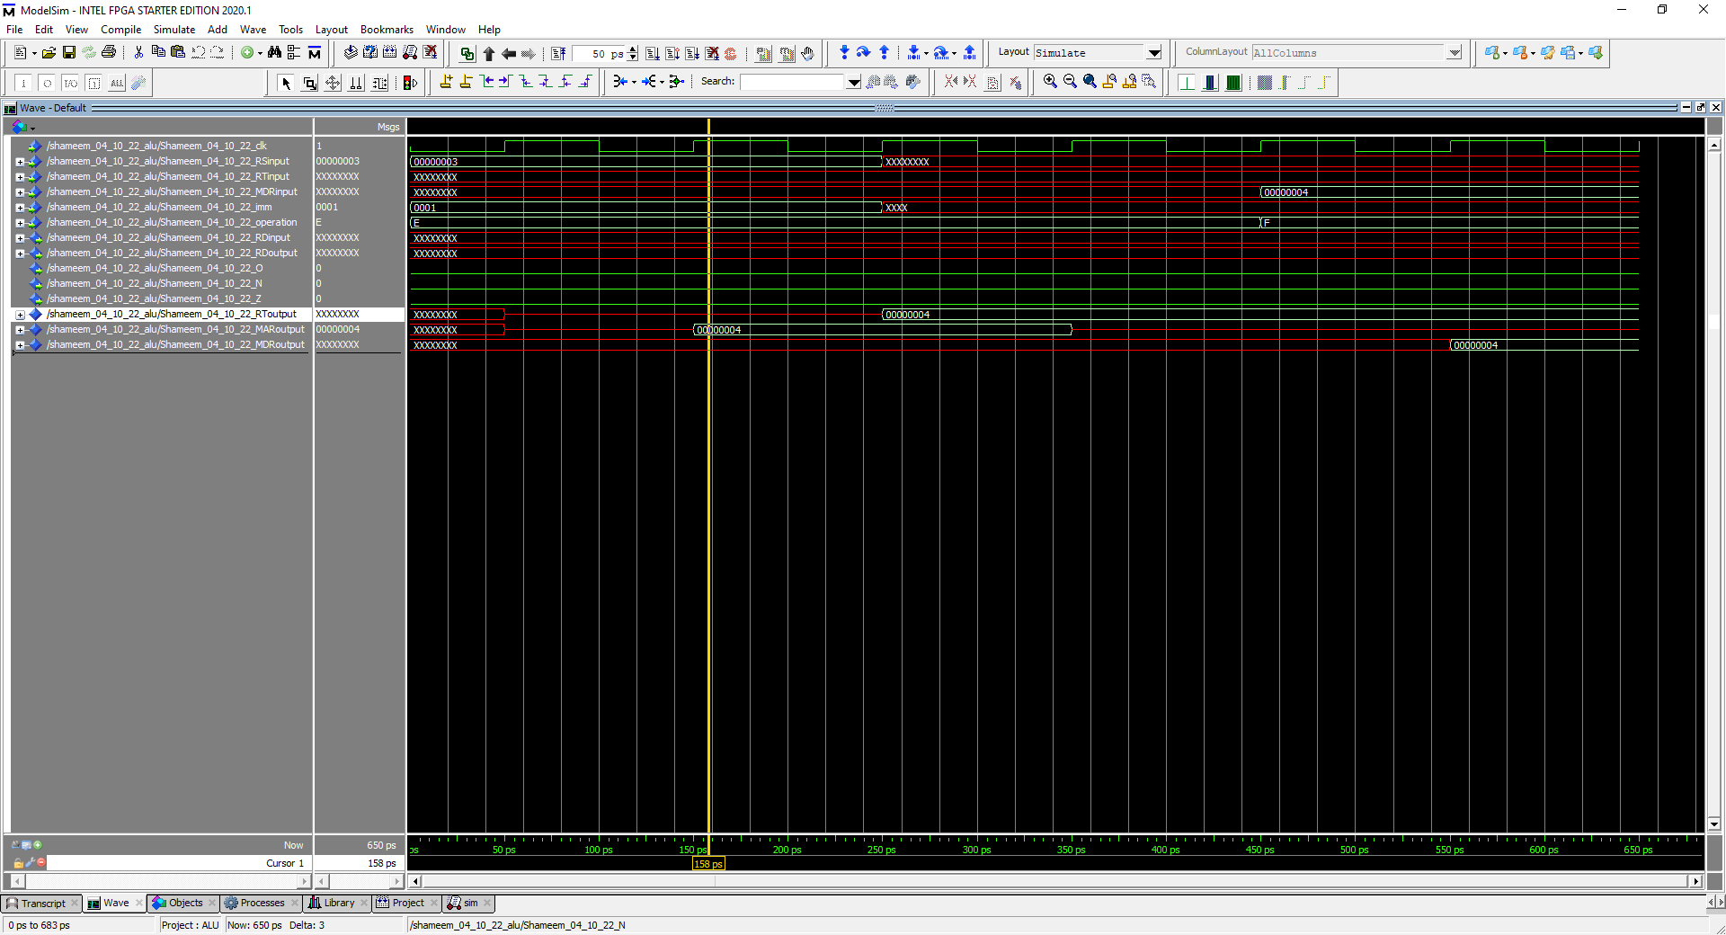

Figure 93: Simulation to represent SW (radix is hexadecimal for everything)

R [rt] (0x00000004) = M[R[rs] (0x00000003) + SignExtImm]

In this simulation the operation is 1110 at 450 ps which stands for SW, so it takes RS and SignExtImm and adds them together and outputs them into MDR which then goes into RT. Furthermore, 0x00000003 plus 0x00000001 equals 0x00000004, which means the flags zero and negative should be 0 as shown in the waveform because the output is clearly not negative or zero. The overflow flag is also 0 because the output does not trigger the rules of overflow since a positive plus a positive can equal a positive without any overflow.

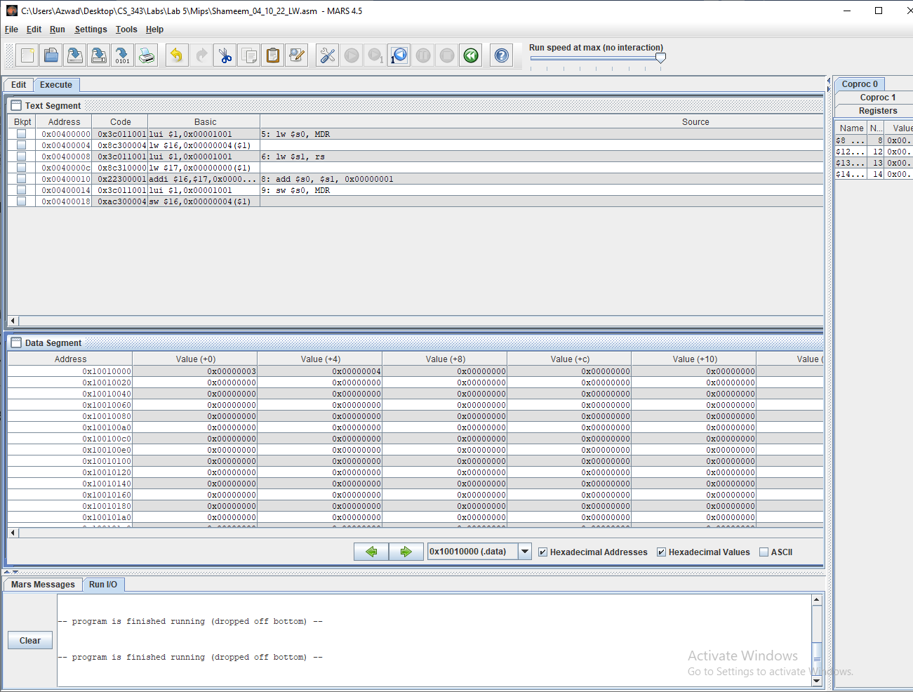

Figure 94: Executed successfully on MARs.

R [rt] (0x00000004) = M[R[rs] (0x00000003) + SignExtImm]

Values RS, MDR shown clearly in data segment, which is 0x00000003 and 0x00000004. The results of the MIPS code on MARS resulted in the same result as on the waveform simulation in figure 91. Therefore, SW is the same on MARS and ModelSim waveform, so the VHDL code for SW is working correctly.

# Conclusion:

The Arithmetic Logic Unit lab was an important step because it allowed us to implement MIPS instructions in VHDL. MIPS instructions such as ADD, ADDU, SUB, SUBU, AND, NOR, OR, SLL, SRA, ADDI, ADDIU, ANDI, ORI, LW, SW was to be implemented by VHDL programming. Furthermore, the VHDL program that implemented MIPS instructions was then to be tested by utilizing ModelSim simulations and MIPS instructions on MARS in order to verify correctness. After completing the Arithmetic Logic Unit lab, we have taken a step forward closer to making a CPU because we have proved that we can create instructions that a CPU may have taken through VHDL programming.